**AIR FORCE MANAGEMENT SYSTEM**



**Session 2023 - 2027**

**Submitted by:**

Sumaira Hafeez 2023-CS-1

**Supervised by:**

Sir Dr. Awais Hassan

**Course:**

CSC-103 Object Oriented Programming

Department of Computer Science

**University of Engineering and Technology**

**Lahore Pakistan.**

Table of Contents

1.

• **Short Description of your project** 3

• **Users of Application (3 users for my project)** 4

• **Functional Requirements** 4

**OOP Concepts** 5

**Inheritance:** 5

**Polymorphism:** 6

**Abstraction:** 6

**Association:** 6

**Comparison:** 6

**Design Pattern Implementation:** 6

**Classes:** 6

**AFPersonalle:** 6

**Commanding Officers:** 7

**InField Personalle:** 7

• **WIREFRAMES** 9

**1.** **Winform WireFrames** 9

**1.** **Console Based** 23

**Code:** 30

**GDPilot:** 30

**BL:** 30

**DL With DataBase:** 31

**DL With File Handling:** 39

**Interfaces:** 49

**Console Code:** 50

**Main Program:** 50

**UIMission:** 52

**UIRequest:** 55

**UICommanding Offciers:** 56

**UI IT:** 57

**UIGDP:** 58

**Console Utility:** 61

• **Future Directions** 66

**AIRFORCE MANAGEMENT SYSTEM**

# **Short Description of project**

Air Force Management system is concerned about the management of the affairs of air Force. Where they can view their missions, their career slope, their posting details and many other things. This management system is concerned about the internal working and mechanism of Air Force and is a way to digitalize that system. The Air Force Management System is a centralized software solution designed to streamline administrative and operational tasks within an air force organization. It includes features for personnel management, mission tracking, flying hours recording, request management, and user-friendly console-based interface. The system enhances efficiency, decision-making, communication, and compliance within the air force, ultimately contributing to mission success.

# **Users of Application (3 users for my project)**

* + This application has three users which are as follow:
  + OC: The commanding officer who is the supervisor of a specific department of Air Force.
  + Officers: The officers working under OC in a specific trade are included in this.
  + IT : The IT department who has control over all the digital system of Air Force

# **Functional Requirements**

|  |  |  |  |
| --- | --- | --- | --- |
| User Story ID | *As a* | *I want to perform* | *So that I can* |
| **1** | OC | Assign Mission | Assign missions to his under officers |
|  |  | CheckMission | To check whether his under officers have completed their mission |
|  |  | PostingOrder | to post his under officers ito a specific location if needed |
|  |  | AddUnderOfficer | If an officer is posted in his section or trade he can add him in his under officers list |
|  |  | CheckAndApproveRequests | If his under officer has requested for any approval or leave he can set its status and either approve it or reject it. |
| **2** | Officers | CRUD for Flying Hour)only if the officer is of GDP(others are not shown this | A pilot can check his flying hours and update them if he has completed a specific set of flyinghours and view them |
|  |  | View Mission | It will show the missions assign to them by their OC |
|  |  | CompleteMission | This bool type functionality will return true if they have completed their mission |
|  |  | Edit Mission | They can set a mission incomplete in edit section or change their successRate. |
|  |  | Request | They can request their Commanding Officers for any type of problem or leave. |
|  |  | View Request | They can view their requests and check their status if they are approved or rejected |
|  |  | Delete Request | They can delete their request if they want to. |
| **3** | IT | Remove Officer | If an officer is retired it will remove them from list. |
|  |  | Add Officer | If a new cadet has passed out it will assign his credentials to him |
|  |  | Edit Account | In case if any mis information is present it will edit the account of the officer |
|  |  | Assign Passwords | The Passwords and PakNo required for signIn will be given by IT Professionsals |
|  |  | View Officers | They can view Officers and search them on the basis of their PakNo |
|  |  | View Application | They can view their applications. |

* **OOP Concepts:**

# **Inheritance:**

There is a Main Class called AFPersonalle which contains all the basic credentials of the Personalle.Its Childs are

1. Commanding Officers
2. InFieldPersonalle; which is a Parent class of another subclass i.e GDPilots.
3. IT: They are also inherited by the AFPersonalle class but is incomplete.

# **Polymorphism:**

Static polymorphism is seen in Validations Class where an object is validated on many basis in many functions.

Dynamic polymorphism is seen in In Field Personalle class where some functions are made virtual whose child class overrides them.

# **Abstraction:**

Interfaces are applied on the DataLayer of all the classes. Whereas the Infield Personalle Class is also made abstract on the context that in future if a salary attribute is added in it will be different for different types of personalle furthermore, the request is also different for different type of user.

# **Association:**

There is an aggregation among Commanding Officers and their Under Officers and among Mission,Request and GDPilots.

# **Comparison:**

These concepts make the code maintainable and reusable which allow us to code with more efficiency.

# **Design Pattern Implementation:**

● Library Formation: DLL is made of BL and DL in a separate file that has been used in winform and console project.

● Object Handler: An Object Handler is defined to set all the objects of interface according to the requirement either a db or fh.

● Singleton Principle: A singleton is implemented on the dl and IT professionals.

# **Classes:**

## **AFPersonalle:**

private string Name;

private string Rank;//their designantion

private int PakNo;//The number assigned to them by AIR Force

private string PresentlyPosted;

private string Password;

private string Branch;//It tells the location of the personalle

//It will include two contsructors one by default and other parameterized

public AFPersonalle()

{

}

public AFPersonalle(string name, string rank, int pakNo, string presentlyPosted)

{

SetName(name);

SetPakNo(pakNo);

SetRank(rank);

SetPresentlyPosted(presentlyPosted);

}

## **Commanding Officers:**

//This consist of the attributes of OC

private string Squadron;

private List<InFieldPersonalle> UnderOfficers;

//Define constructors

public CommandingOfficers() { }

public CommandingOfficers(string Name, string Rank, int PAkNo, string PresentlyPosted, string Sqadron):base(Name, Rank, PAkNo,PresentlyPosted)

{

SetSquadron(Sqadron);

UnderOfficers = new List<InFieldPersonalle>();

}

# **InField Personalle:**

public abstract class InFieldPersonalle:AFPersonalle

{

private string Squadron;//This attribute refers to the squadron the officer is belongigng to

private List<Mission> Missions;

private List<Requests> requests;

private CommandingOfficers OC;

public InFieldPersonalle(string Name, string Rank, int PakNO, string PresentlyLocated, string Squadron) : base(Name, Rank, PakNO, PresentlyLocated)

{

SetSquadron(Squadron);

Missions = new List<Mission>();

requests = new List<Requests>();

}

public InFieldPersonalle() { }

//Define the getters and Setters

public void SetSquadron(string Squadron)

{

this.Squadron = Squadron;

}

1. **GDPilot:**

public class GDPilot:InFieldPersonalle

{

private int FlyingHours=0;

//SET ITS CONSTRUCTORS

public GDPilot(string Name,string Rank,int PakNO,string PresentlyLocated,string Squadron):base(Name,Rank,PakNO,PresentlyLocated,Squadron)

{

SetSquadron(Squadron);

}

1. **Missions:**

public class Mission

{

private DateTime Date;

private string Details;

private bool IsComplete;

private float SuccessRate;

//It will have a single parameterized Constructor and one default constructor

public Mission()

{

}

public Mission(DateTime date, string details)

{

SetDate(date);

SetDetails(details);

}

1. **Requests:**

public class Requests

{

private int PakNo;

private int RequestId;

private string Context;

private string Status;

//Define its constructor

public Requests() { }

public Requests(int RequestId, string Context,int PAkNo)

{

SetContext(Context);

SetPakNo(PAkNo);

SetRequestId(RequestId);

}

# **WIREFRAMES**

## **Winform WireFrames**

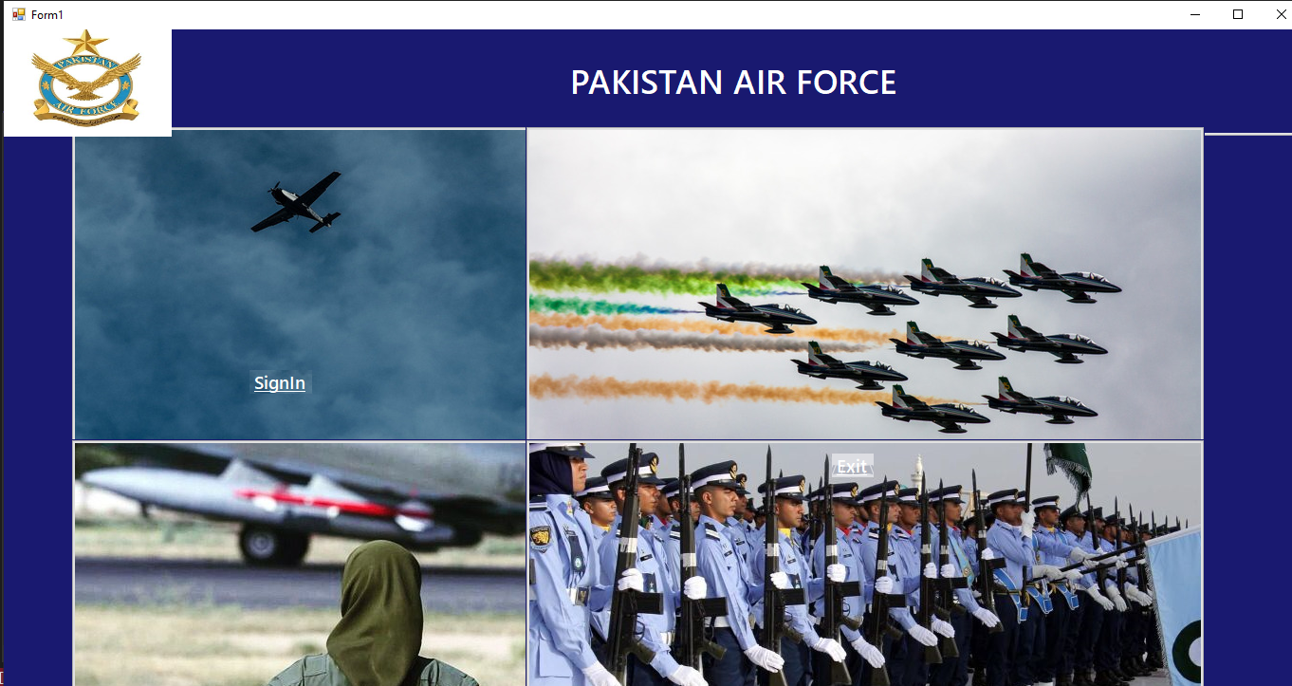

* **First Page**

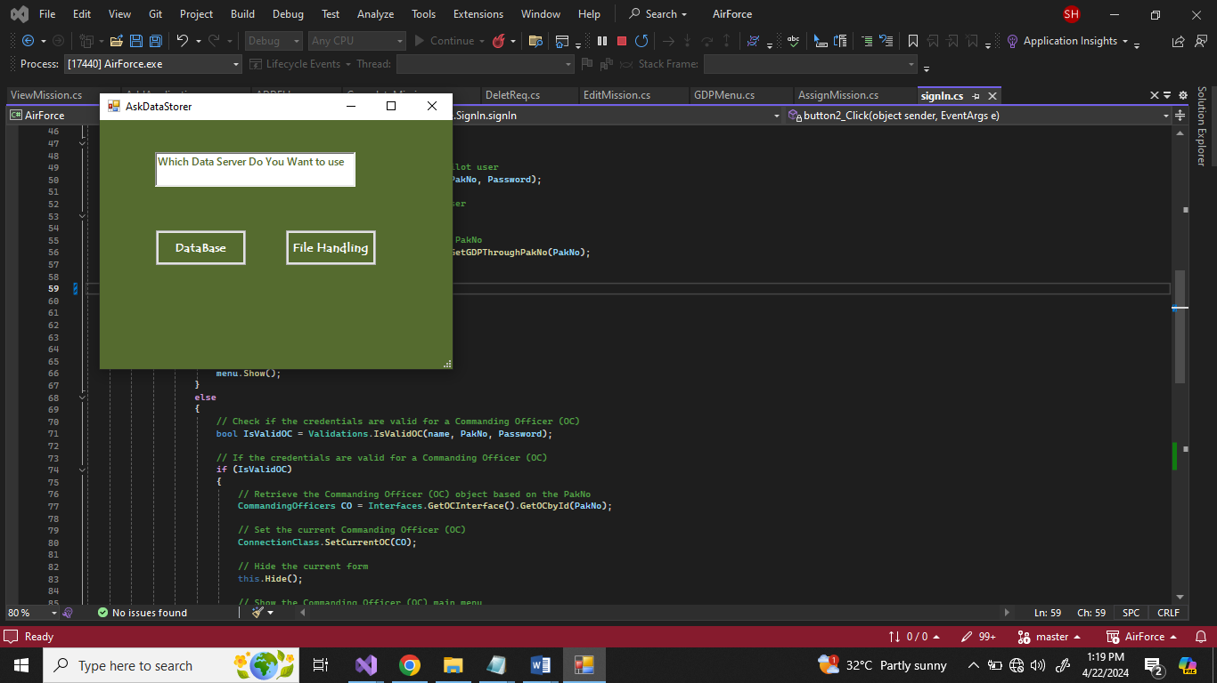

* **Asking DataBase Option**

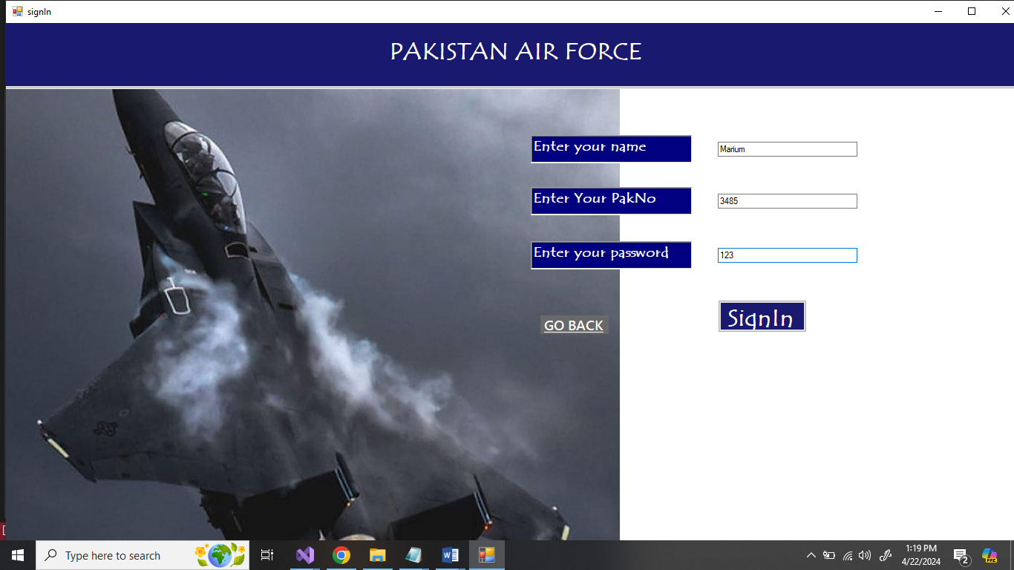

* **Sign In Page**

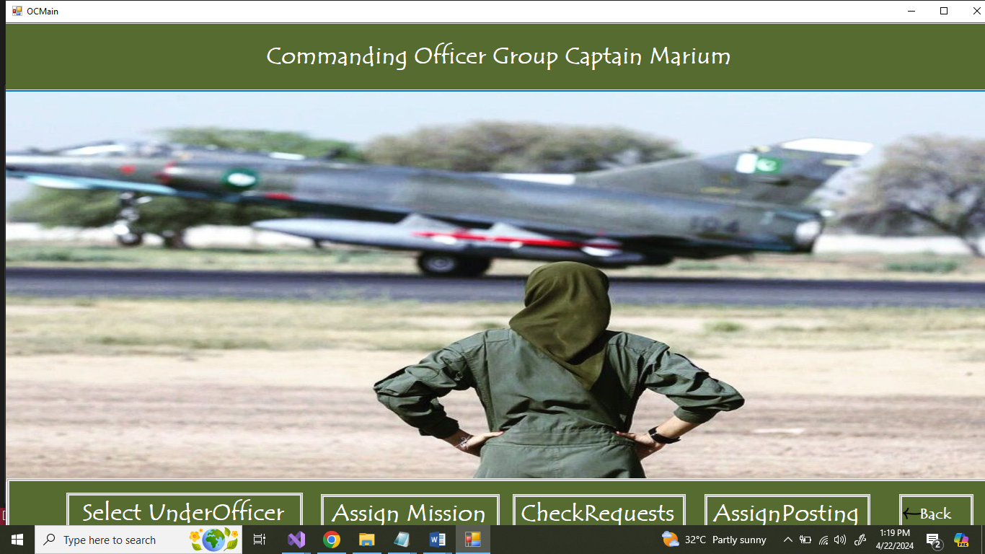

* **Commanding Officer Menu**

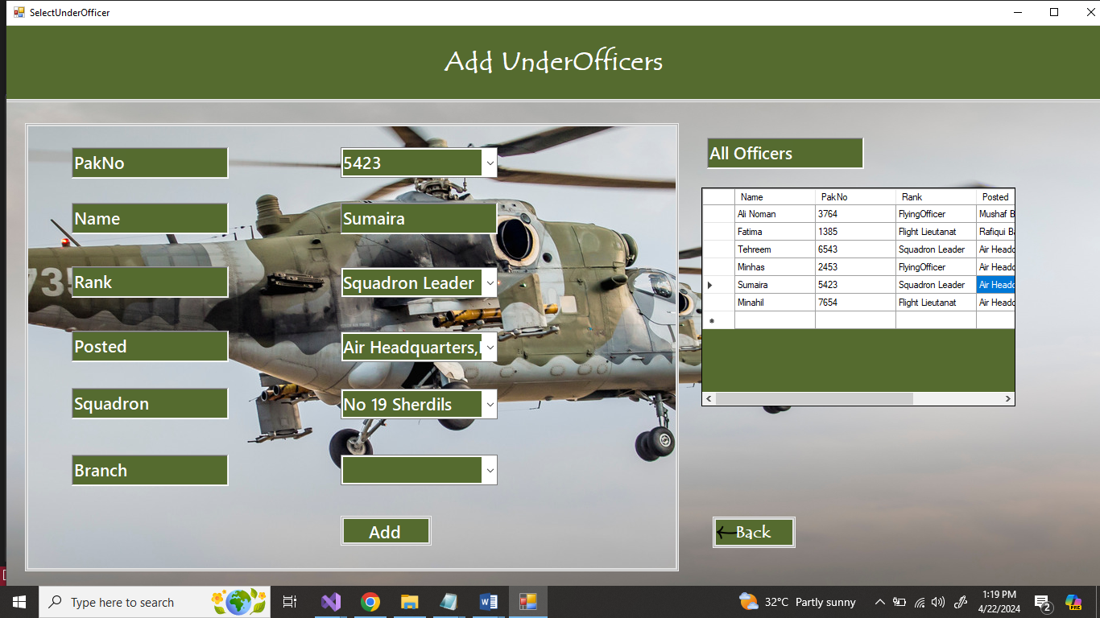

* **SELECT UnderOfficers**

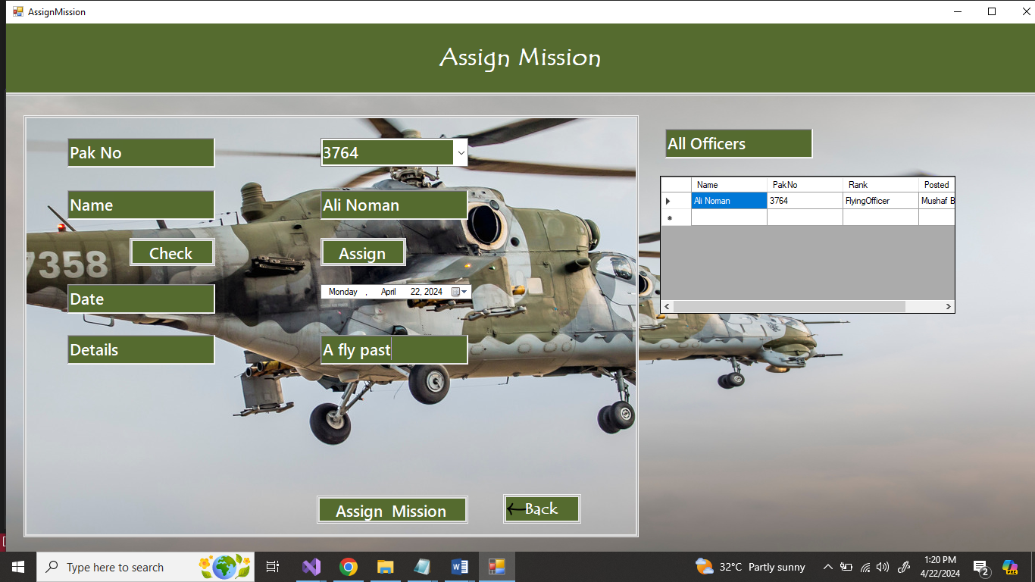

* **Assign Mission**

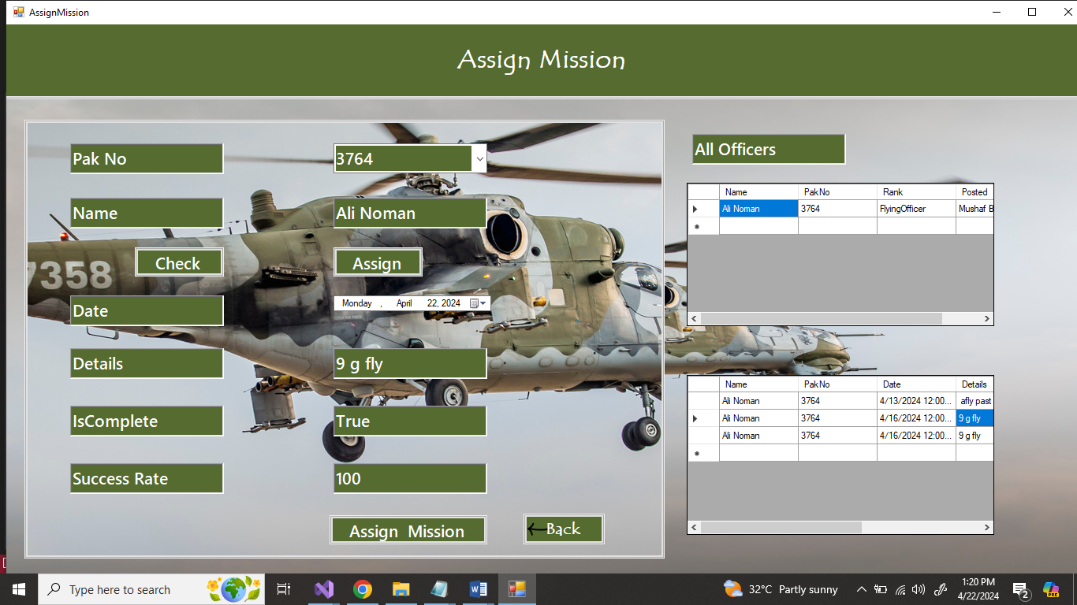

* **Check Missions**

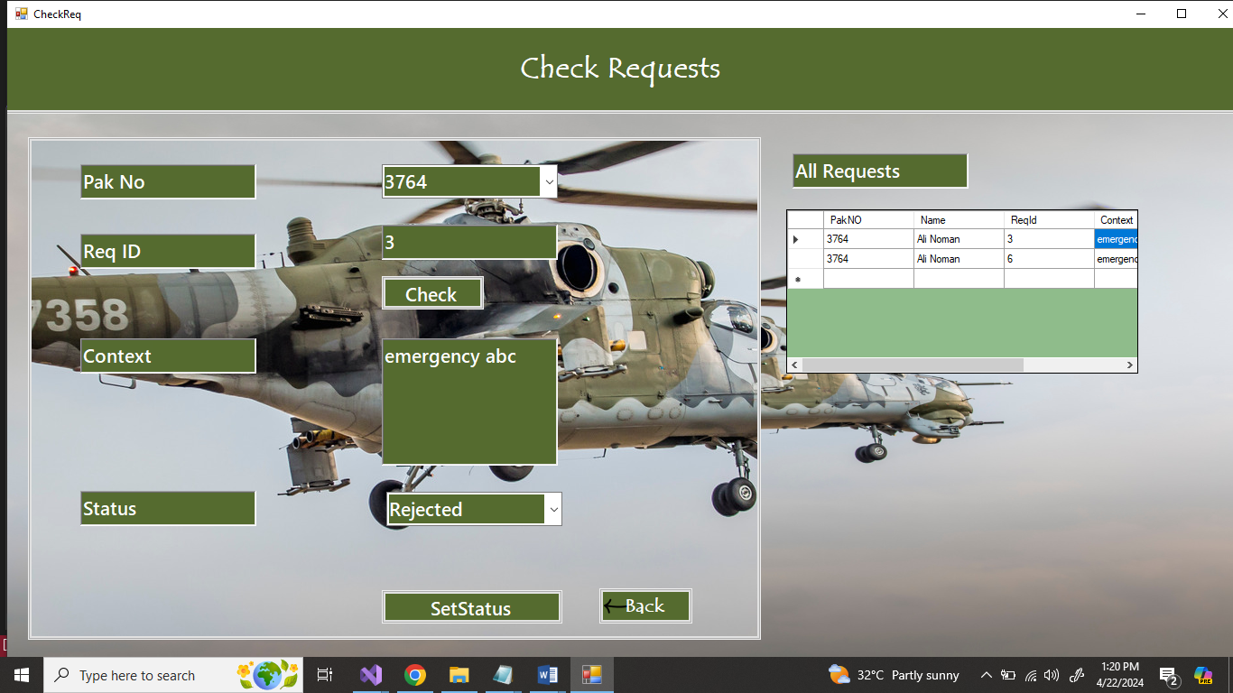

* **Check Requests**

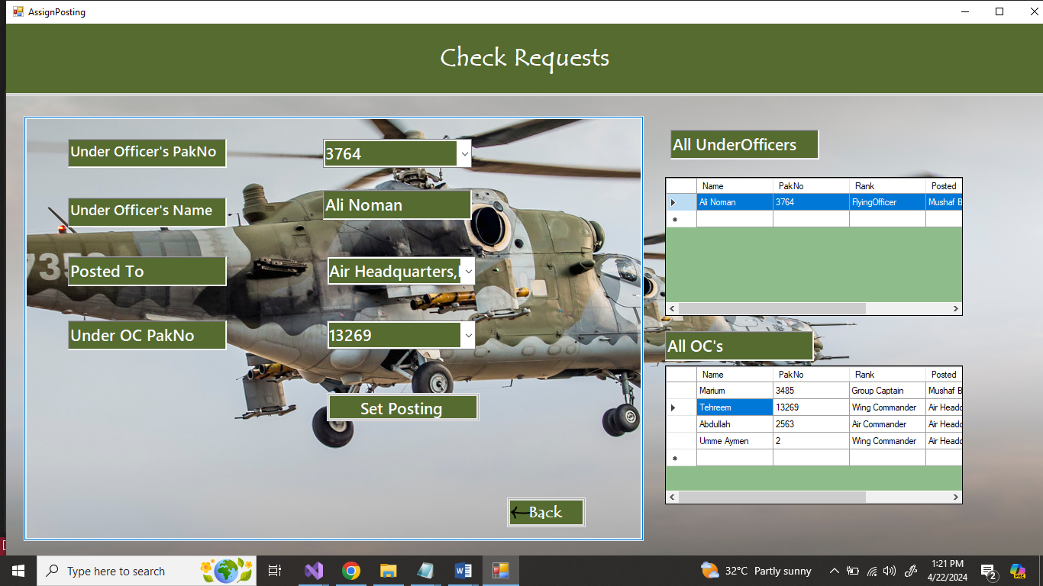

* **Assign Posting**

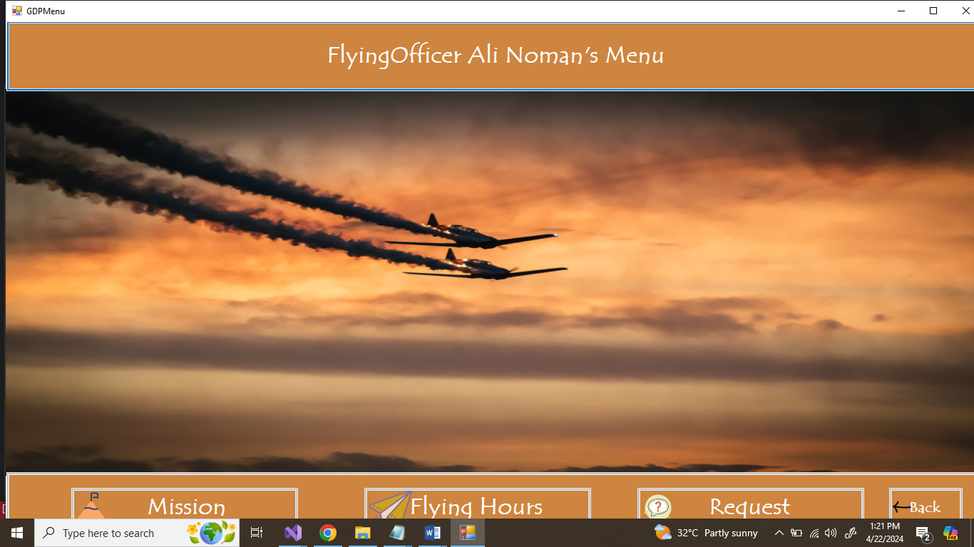

* **GDPilot Main Menu**

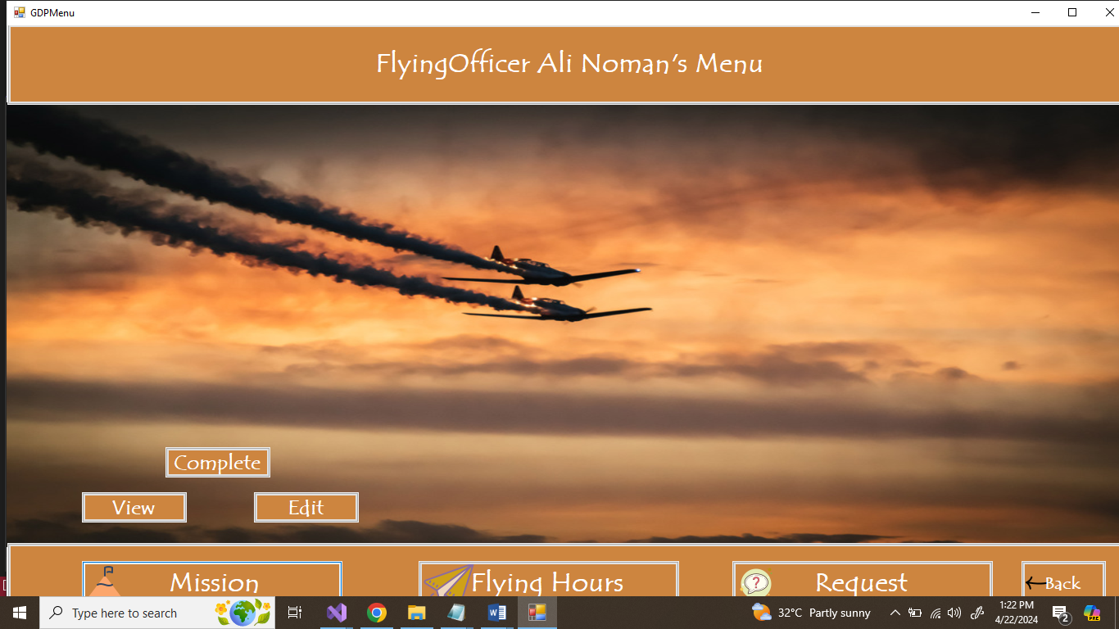

* **Mission Button Click**

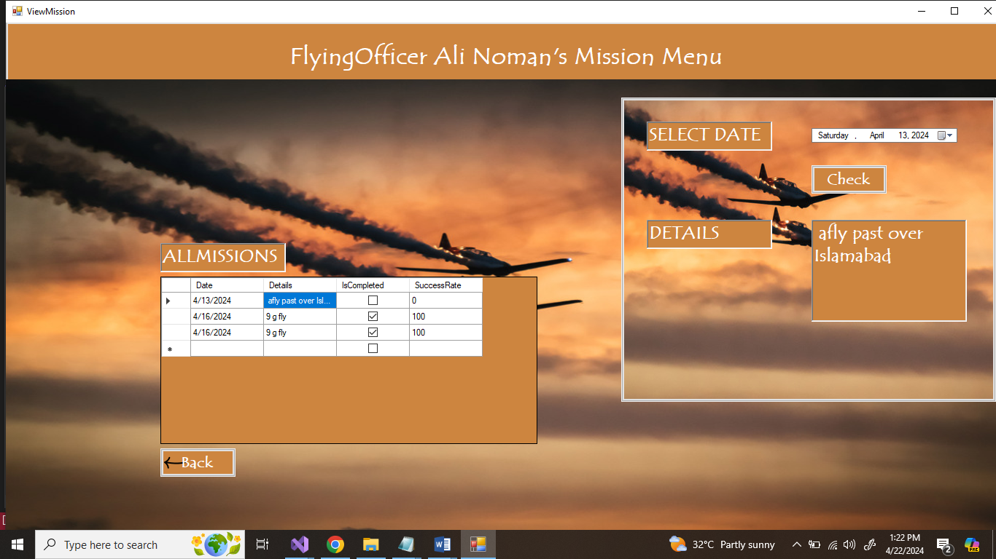

* **View Mission**

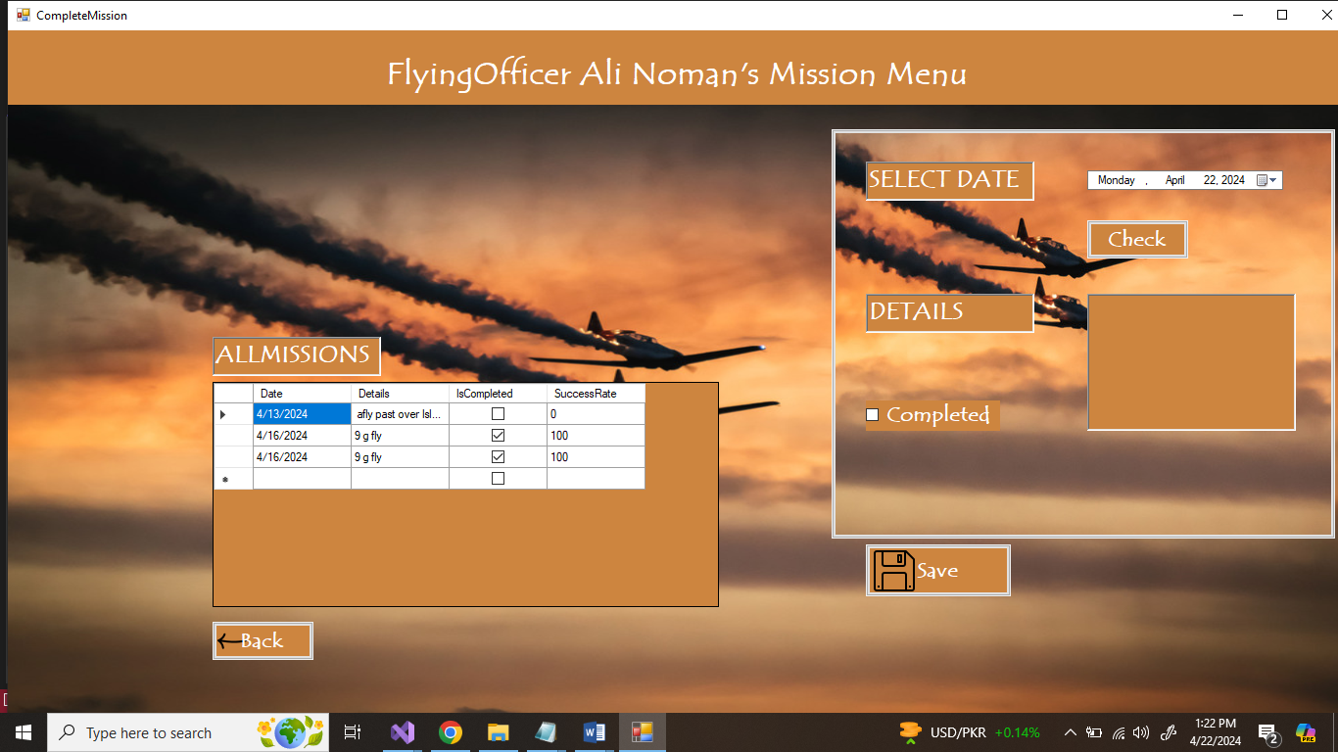

* **Complete Mission**

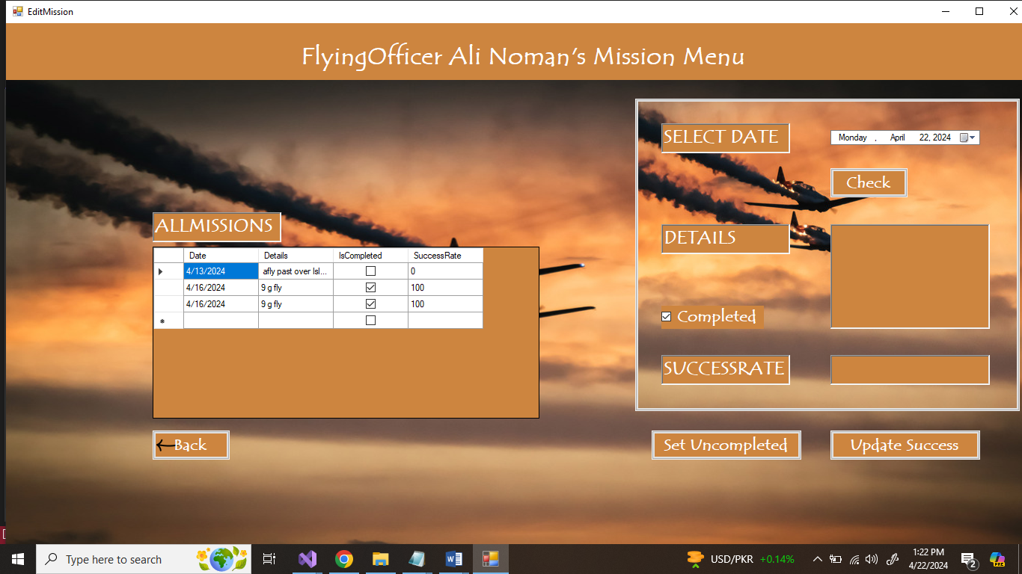

* **Edit Mission**

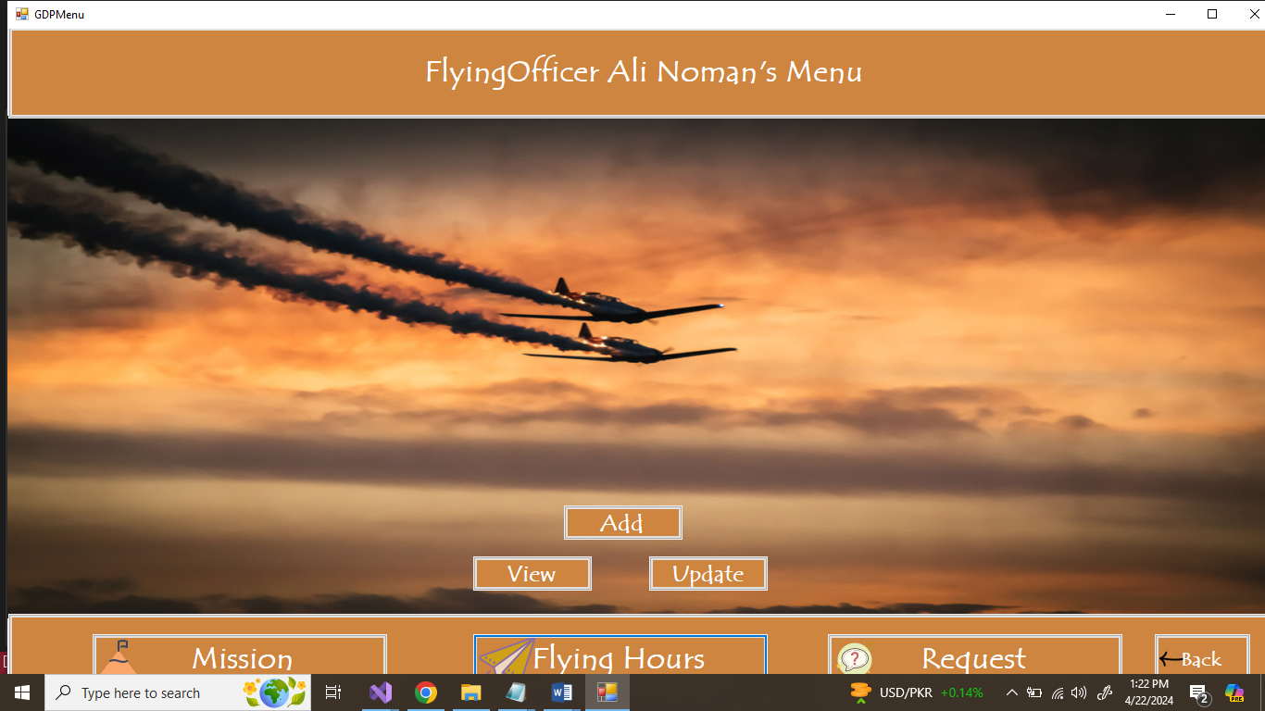

* **Flying Hours Button Click**

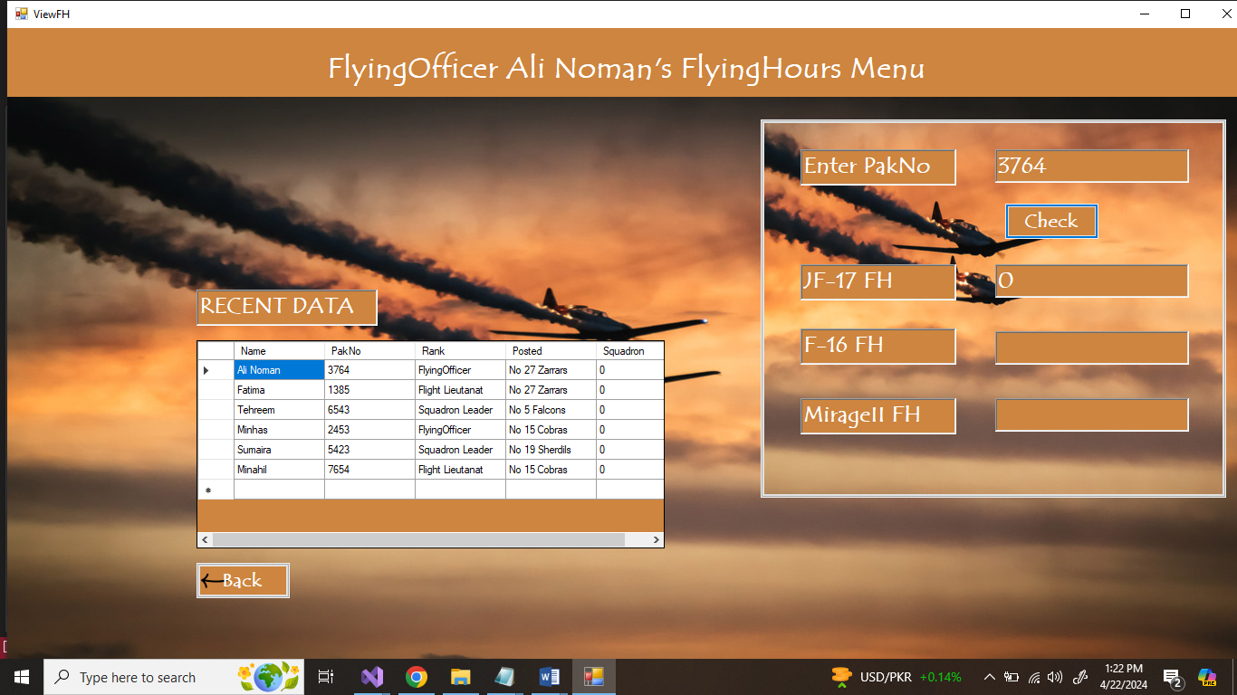

* **View Flying Hours**

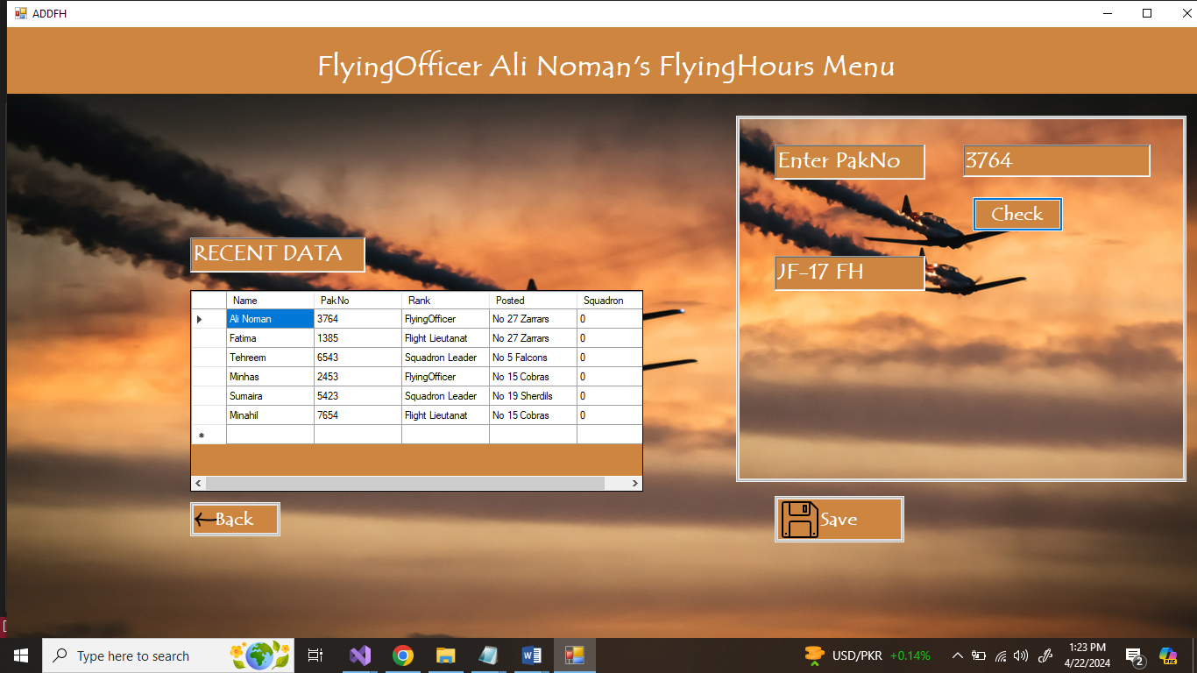

* **Add Flying Hours**

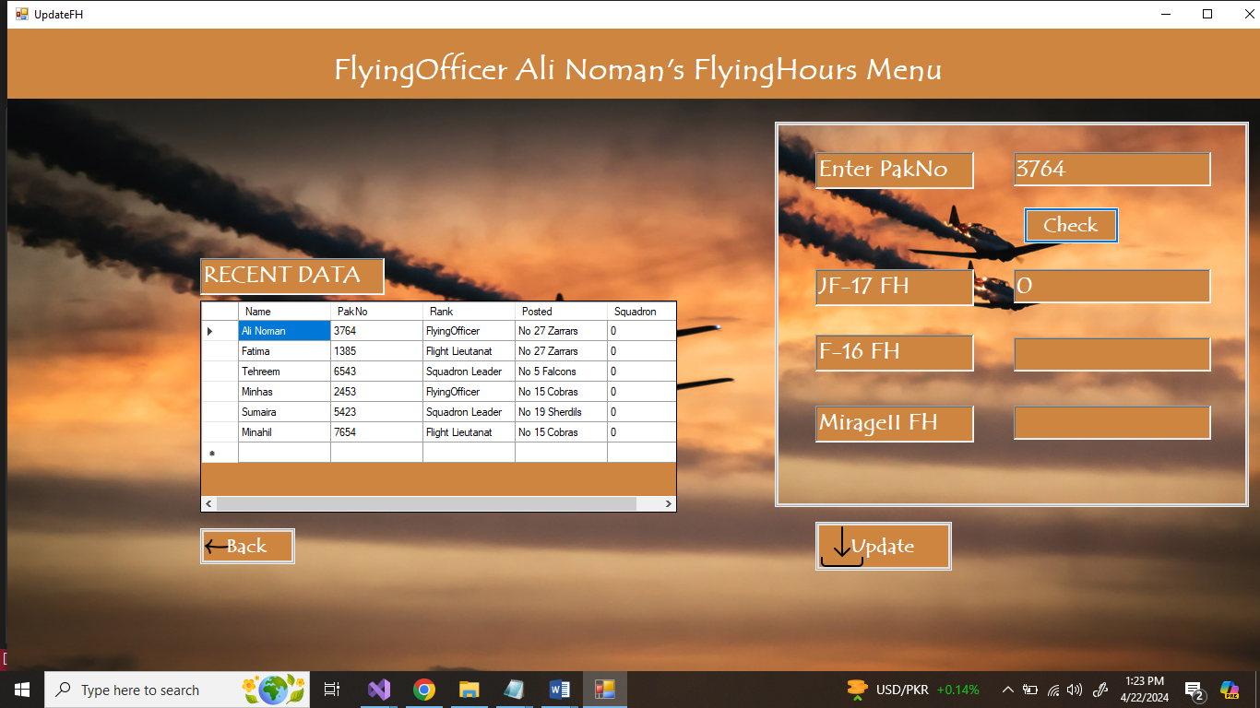

* **Update Flying Hours**

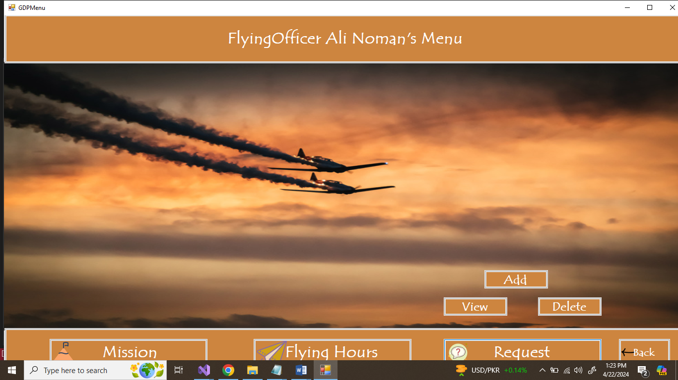

* **Request Button Click**

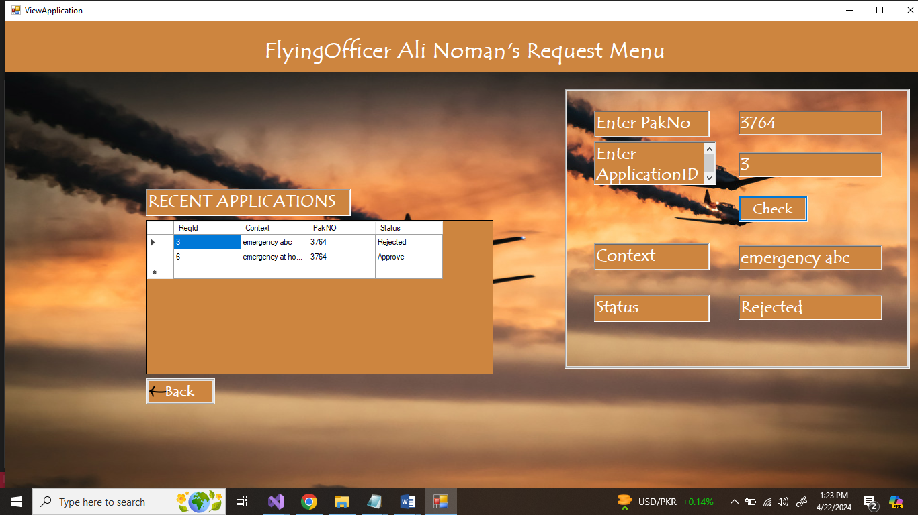

* **View Requests**

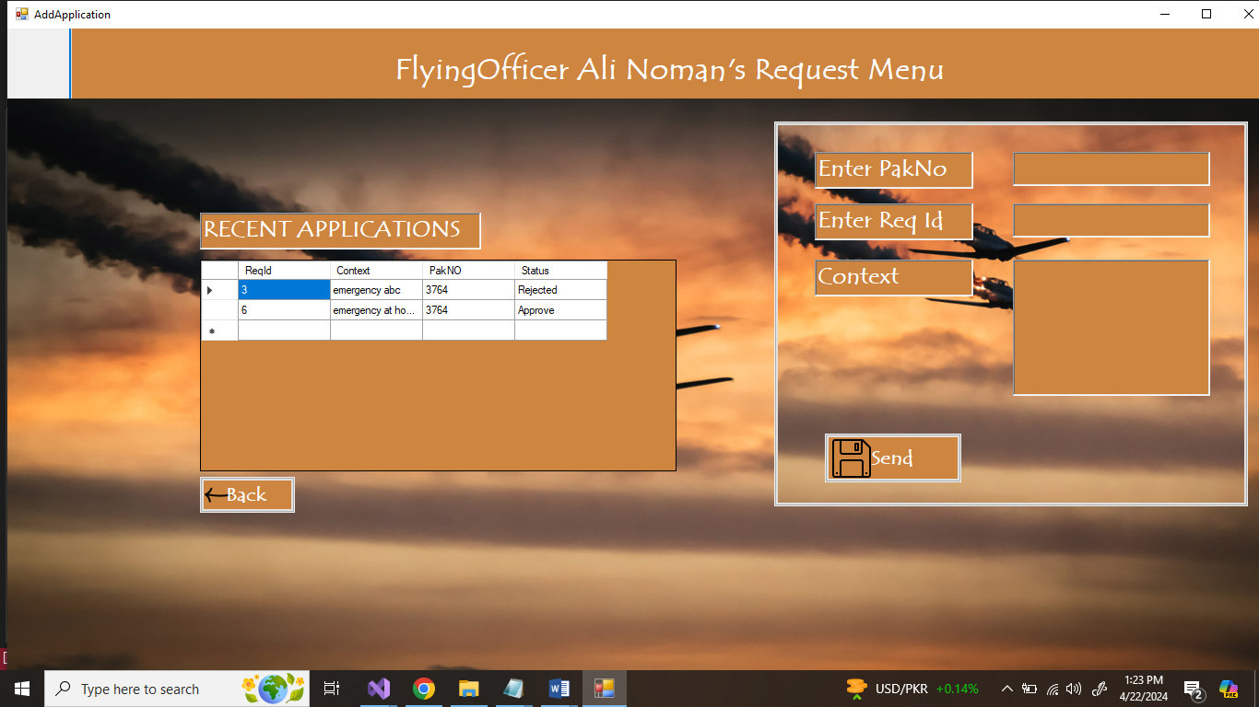

* **Send Request**

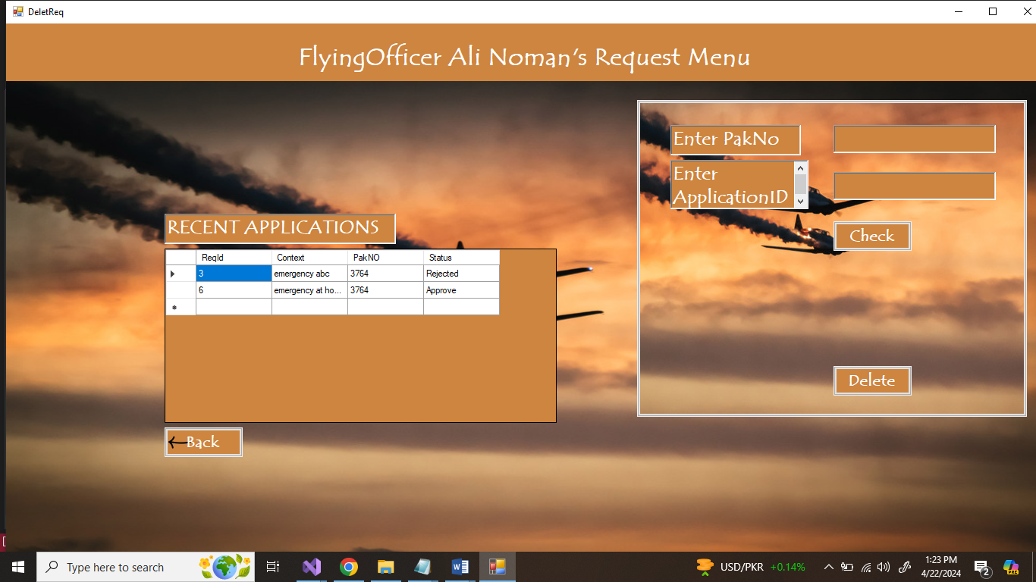

* **Delete Request**

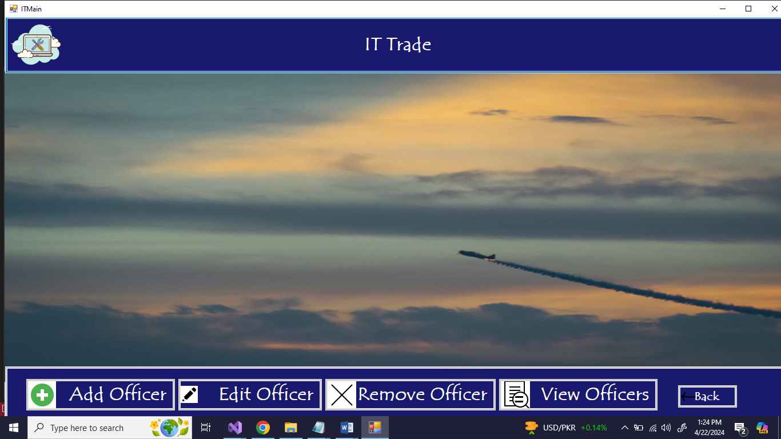

* **IT Main Menu**

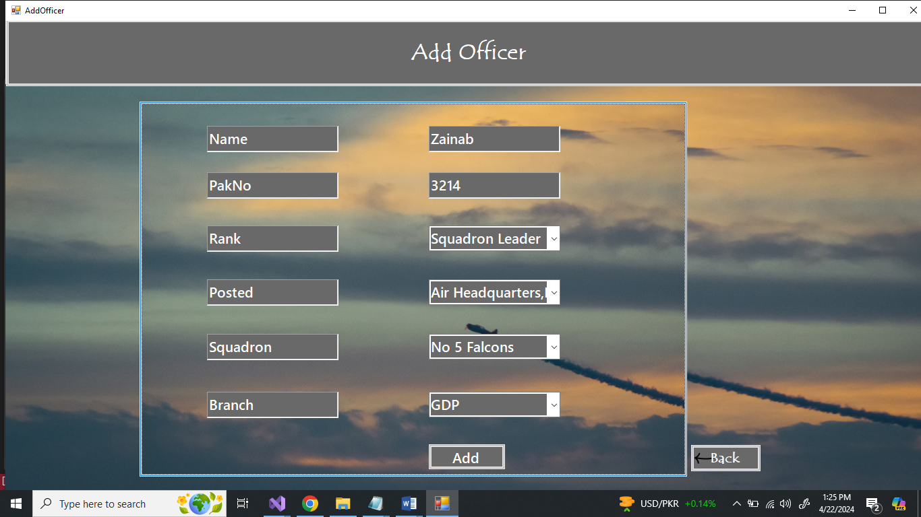

* **Add Officer**

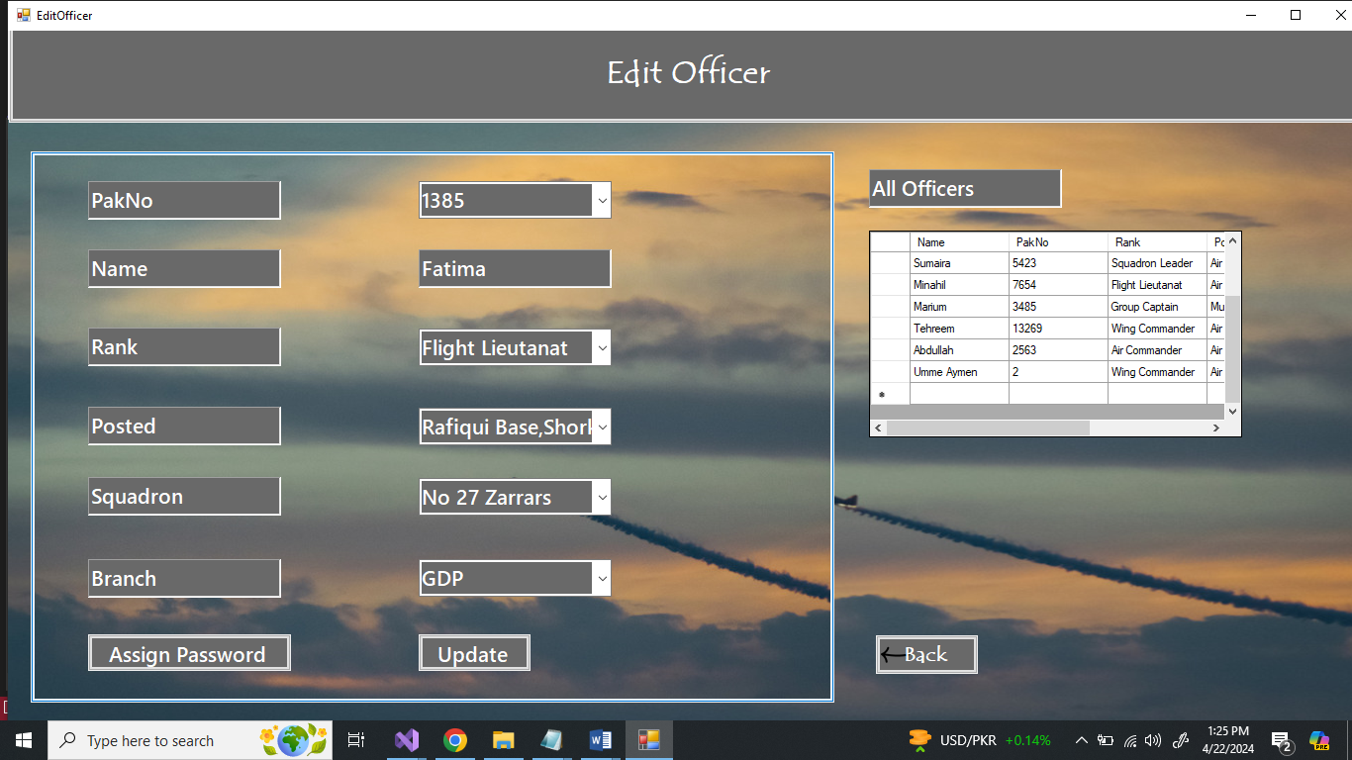

* **Edit Officer**

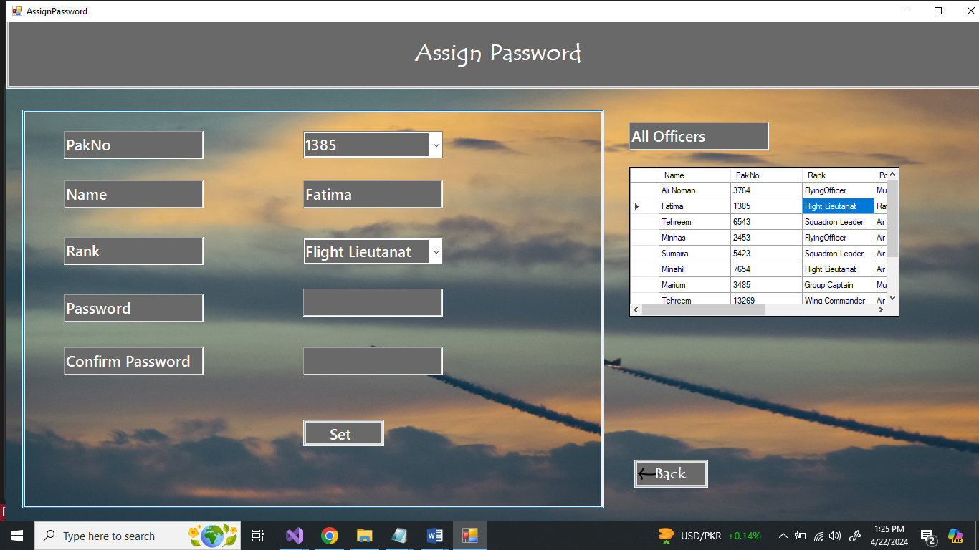

* **Assign Password**

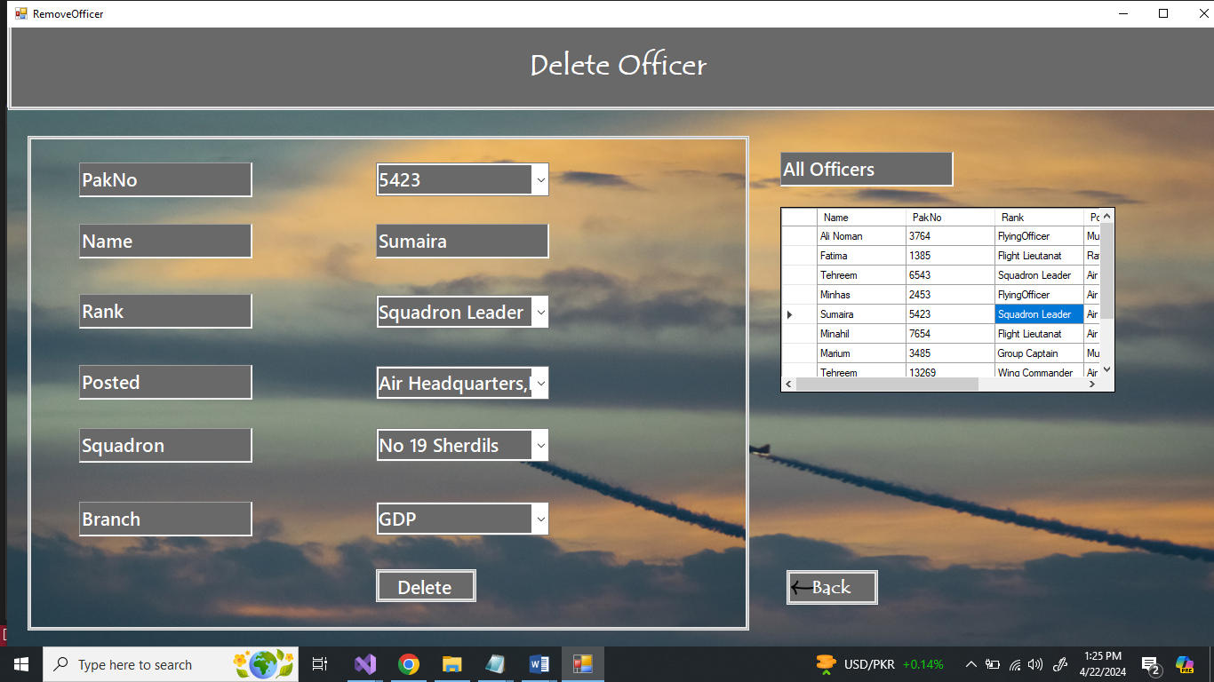

* **Delete Officer**

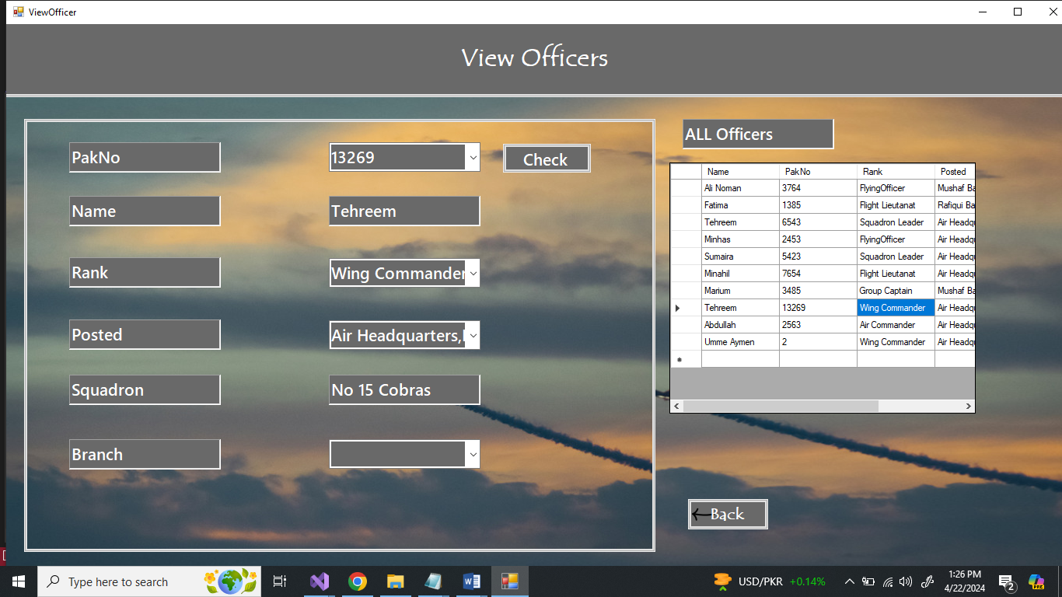

* **View Officer**

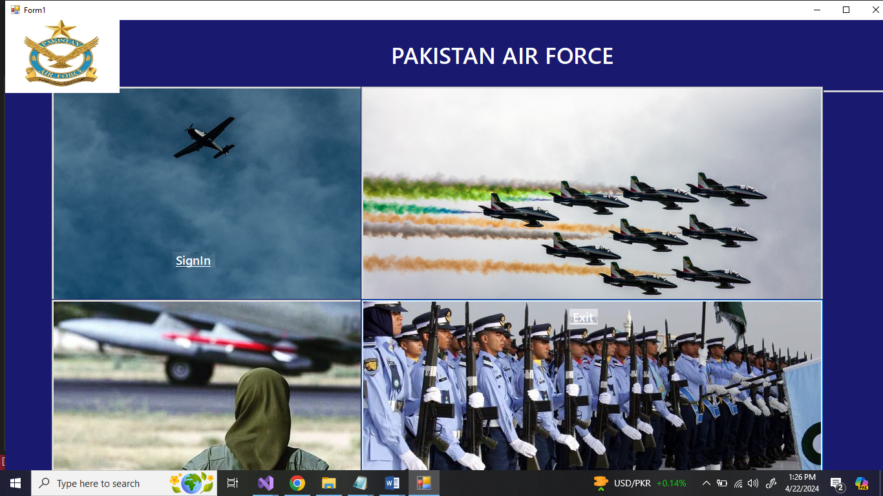

* **Exit Page**

## **Console Based**

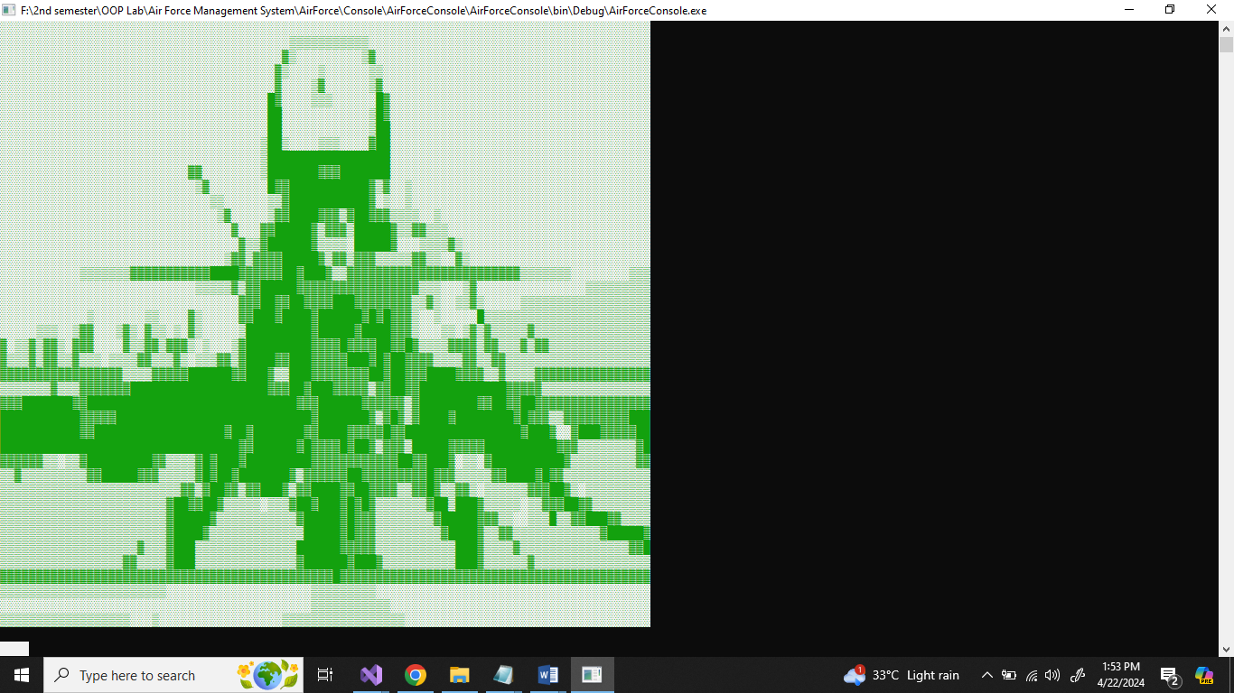

* **Main Page**

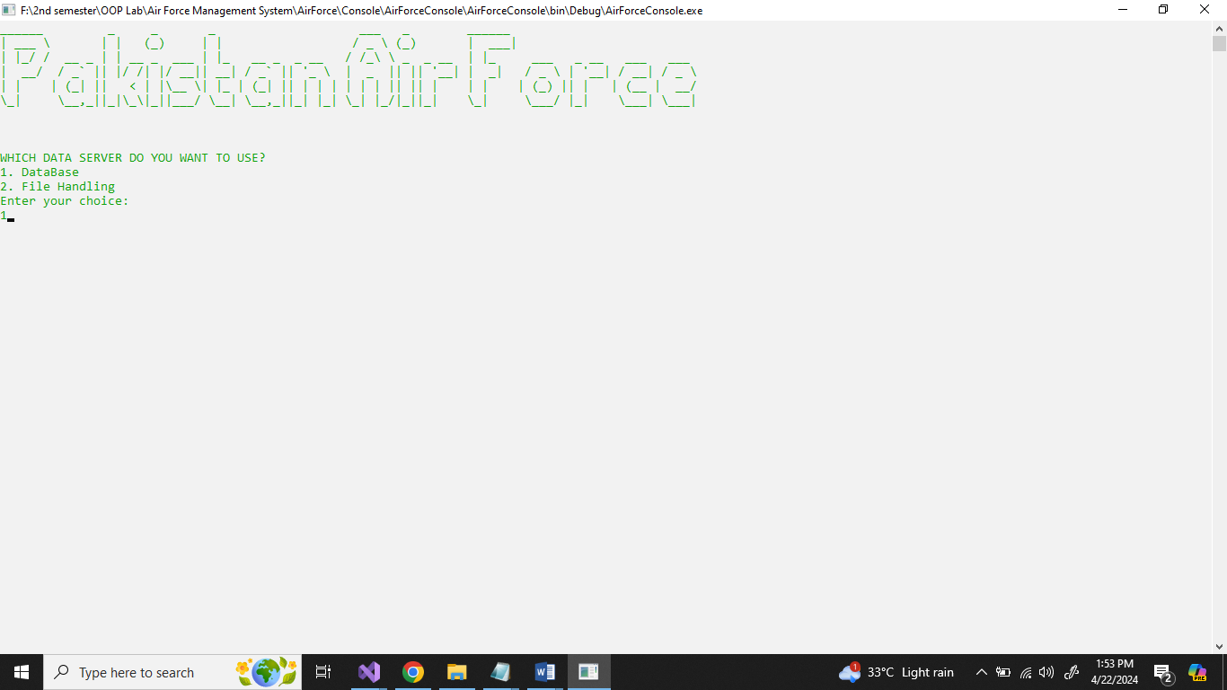

* **DataBase ServerChoice**

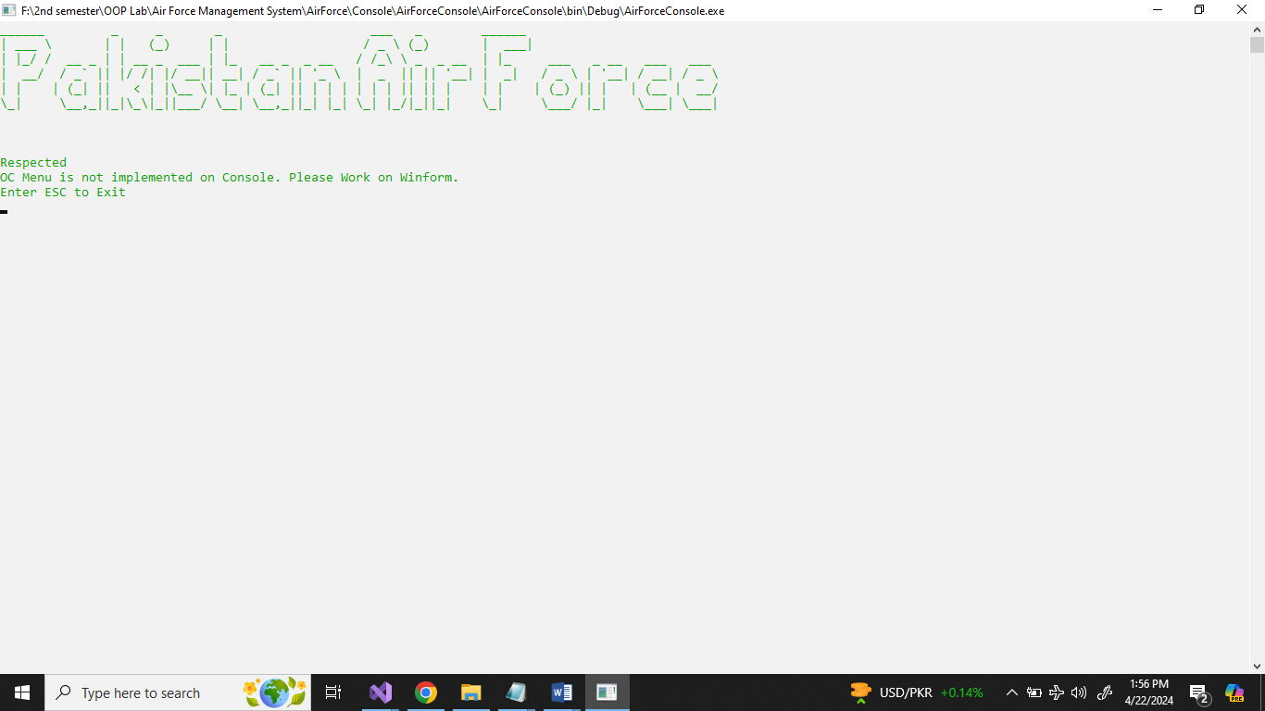

* **OC Menu**

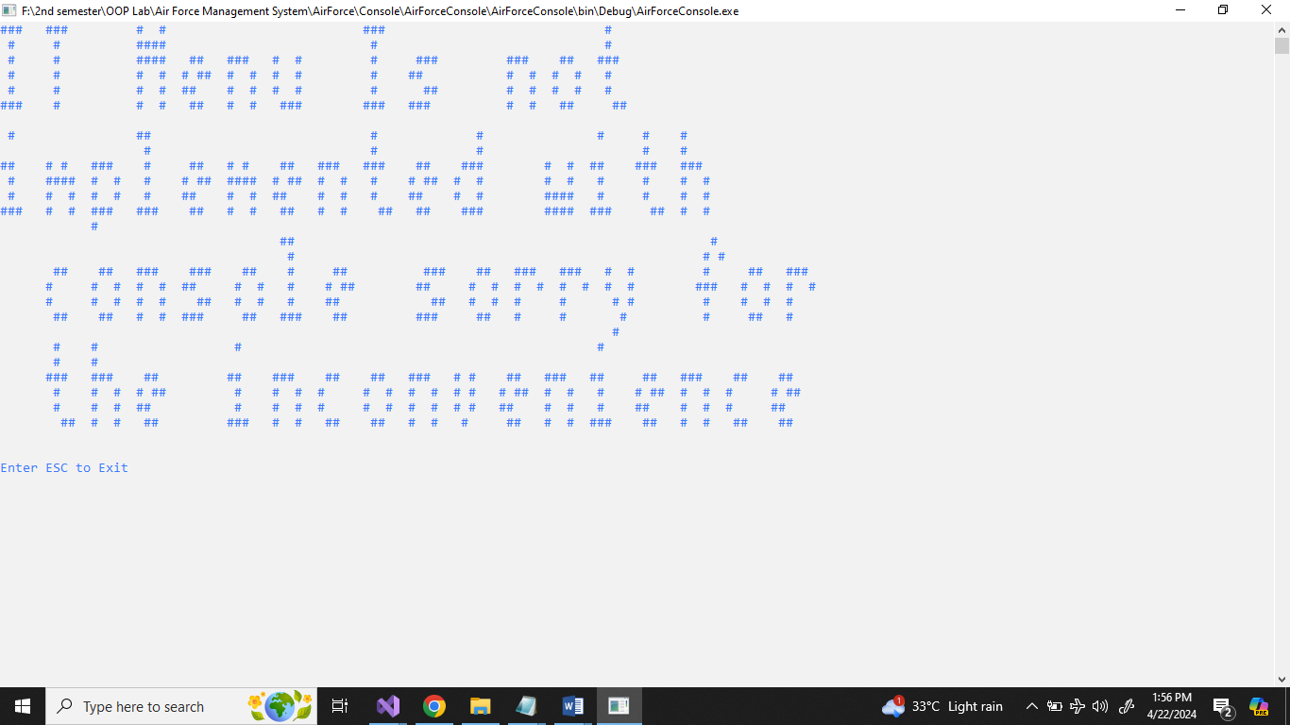

* **IT Menu**

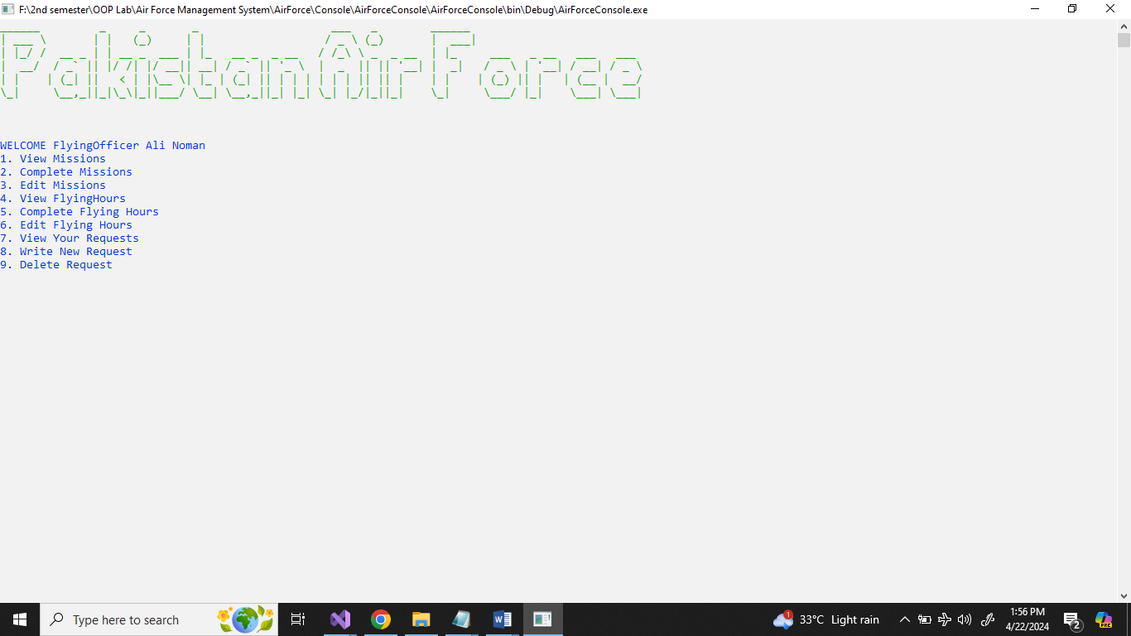

* **GDPilot Menu**

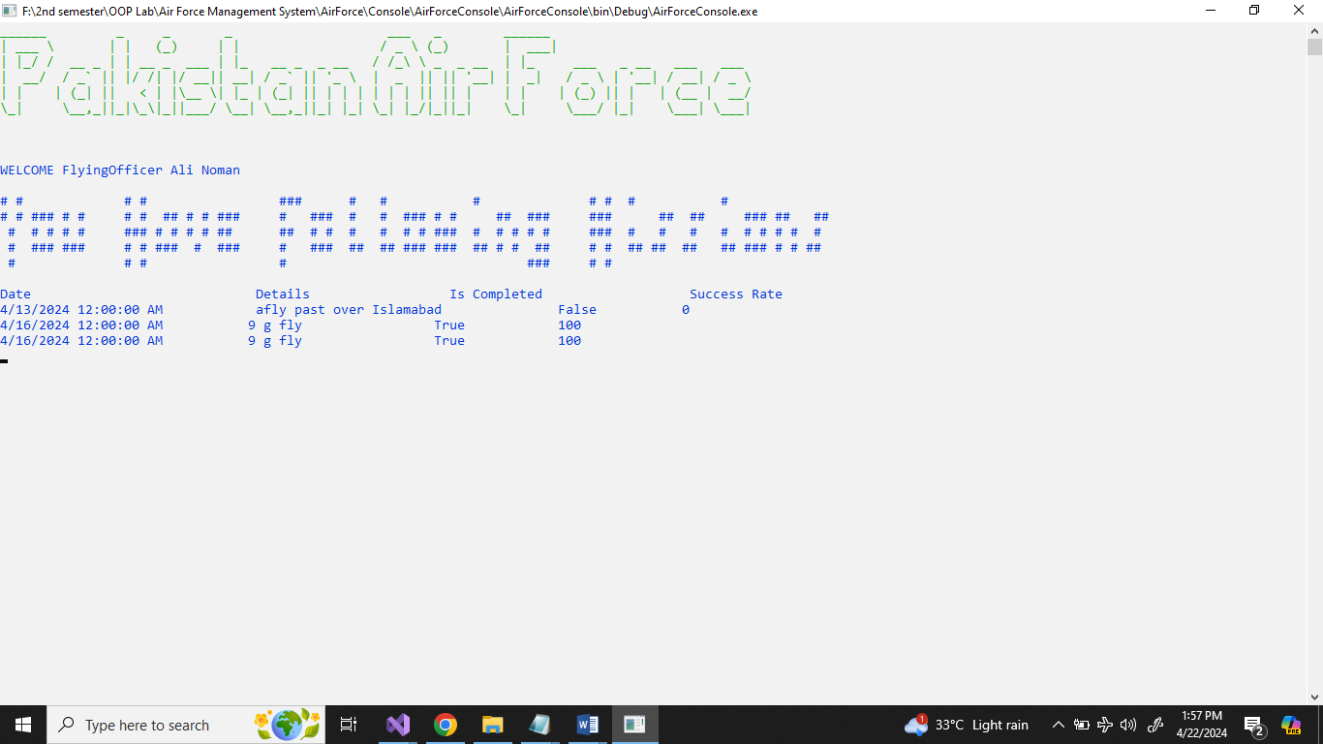

* **View Mission**

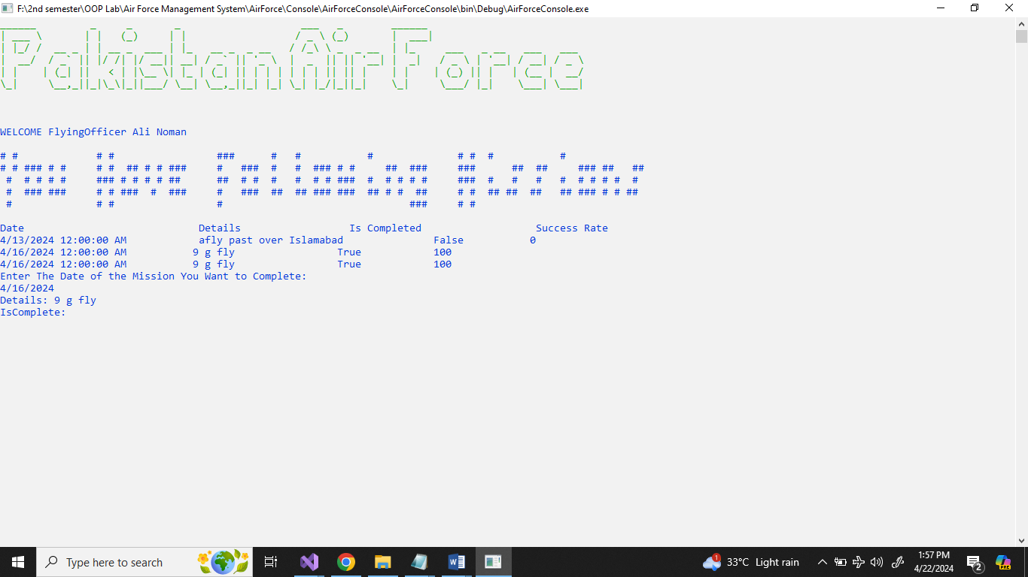

* **Complete Mission**

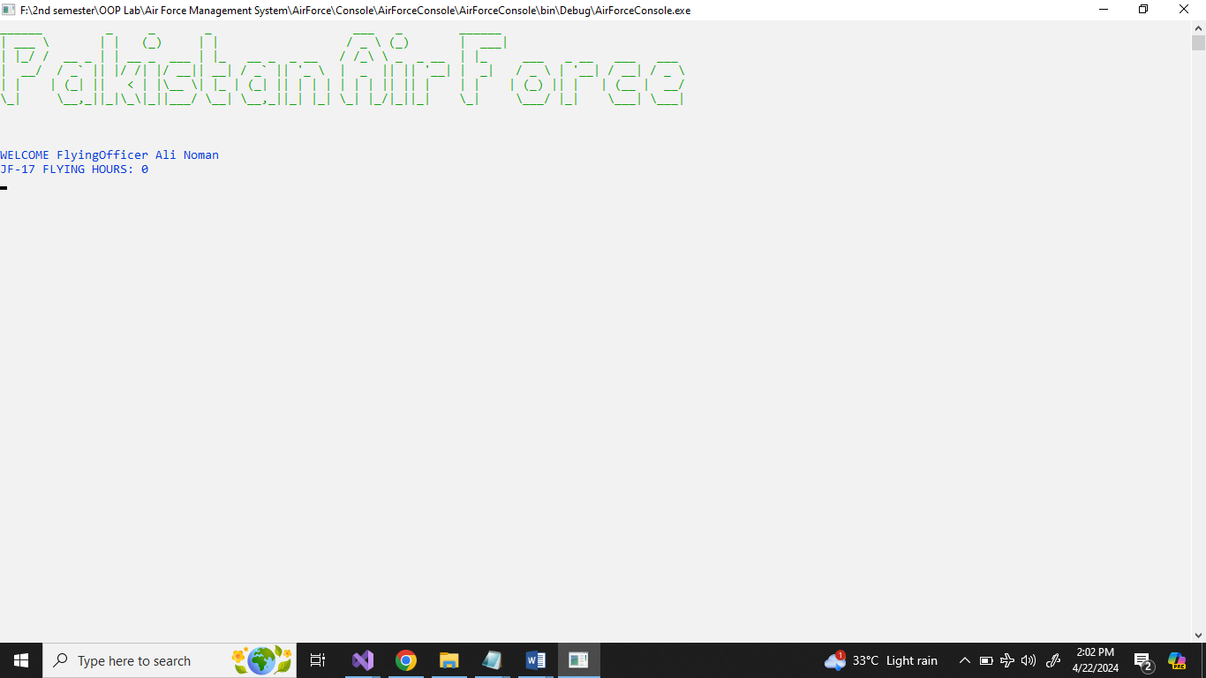

* **View Flying Hours**

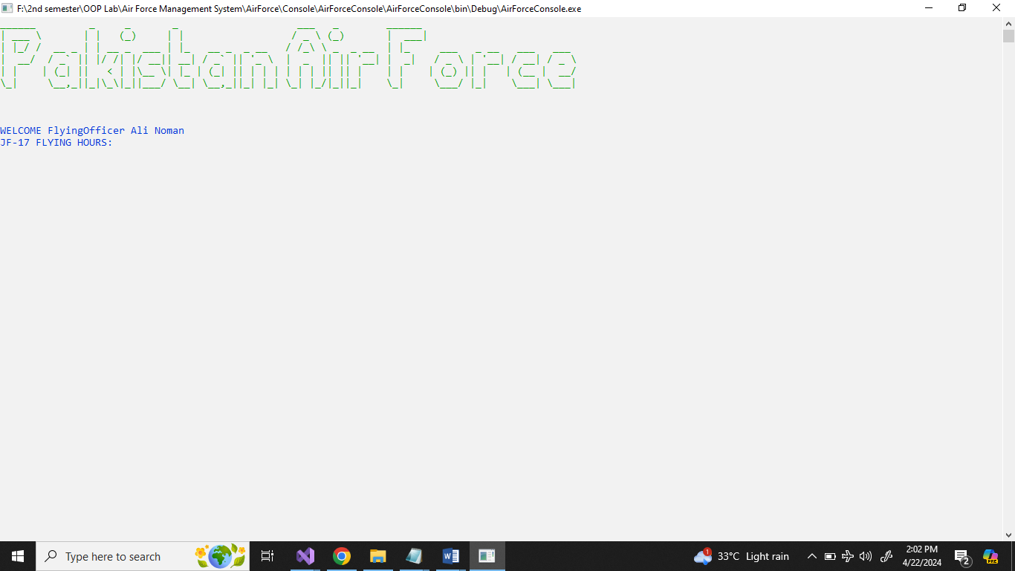

* **Add Flying Hours**

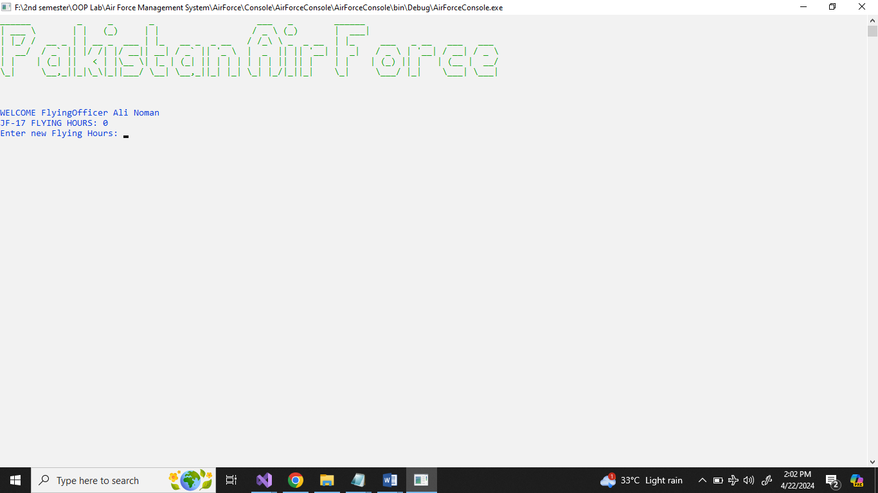

**Update Flying Hours**

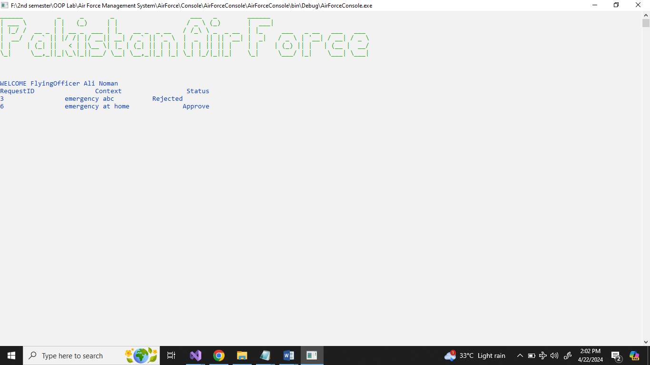

* **View Requests**

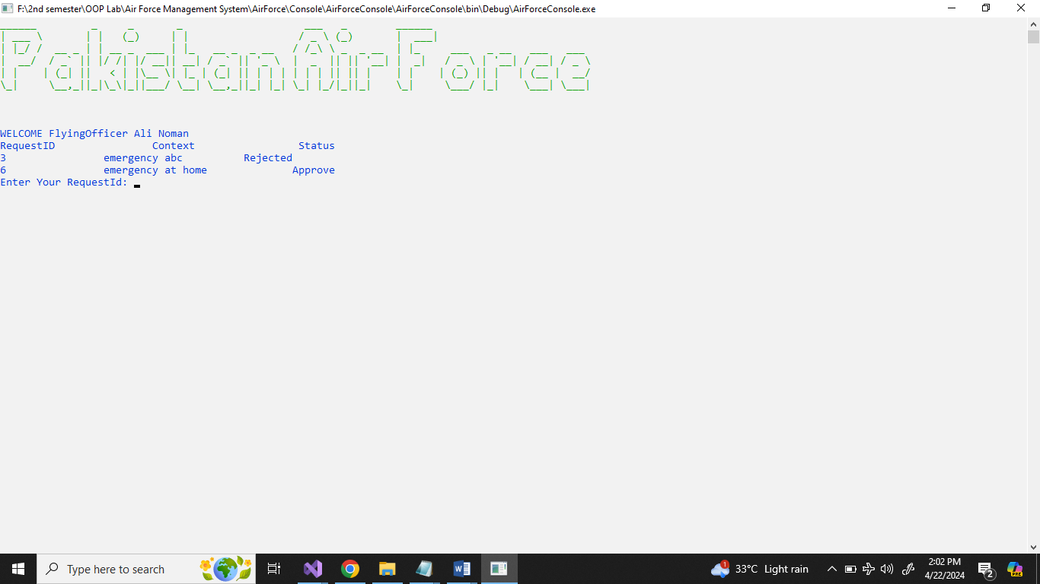

* **New Request**

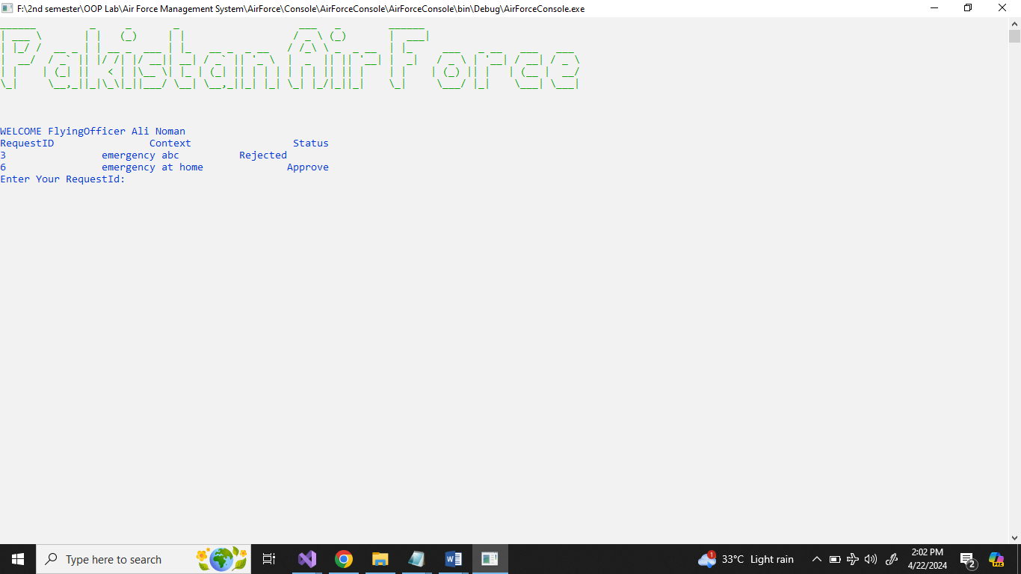

* **Delete Request**

# **CRC**

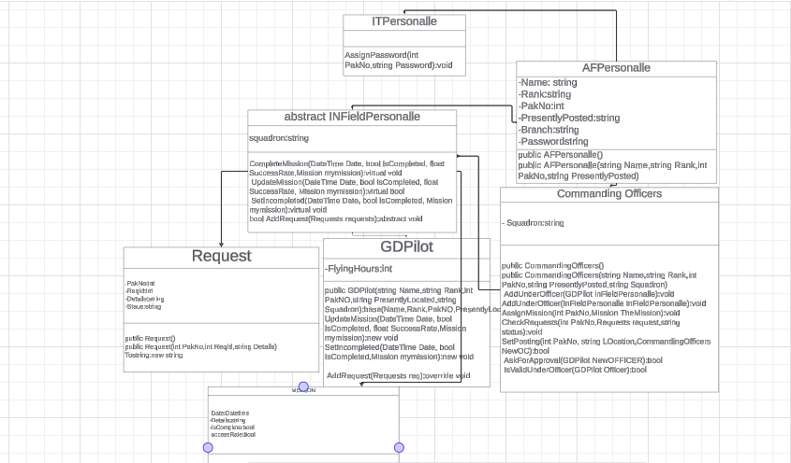

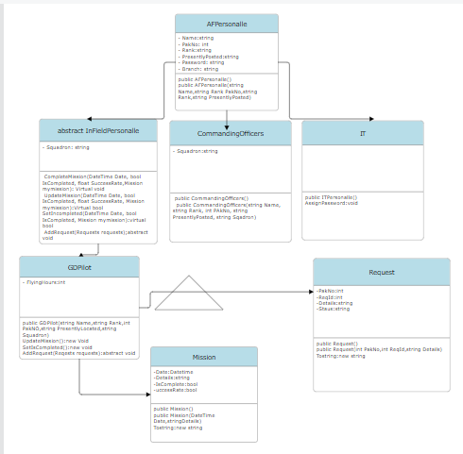

# **Code:**

## **GDPilot:**

### **BL:**

using System;

using System.Collections.Generic;

using System.Linq;

using System.Text;

using System.Threading.Tasks;

namespace AirForceLibrary.BL

{ //This Class is for GDP it is child or base class of AFPersonalle class and is specifically for GDP Officers Under the rank of Group Captain

public class GDPilot:InFieldPersonalle

{

private int FlyingHours=0;

//SET ITS CONSTRUCTORS

public GDPilot(string Name,string Rank,int PakNO,string PresentlyLocated,string Squadron):base(Name,Rank,PakNO,PresentlyLocated,Squadron)

{

SetSquadron(Squadron);

}

//Define its Getters And Setters

public void SetFlyingHours(int FlyingHours)

{

this.FlyingHours = FlyingHours;

}

public int GetFlyingHours()

{ return this.FlyingHours; }

//Define The Behaviors Of the GDP

public new void CompleteMission(DateTime Date, bool IsCompleted, float SuccessRate,Mission mymission)

{

if (IsCompleted)

{

mymission.SetIsComplete(true);

mymission.SetSuccessRate(SuccessRate/10);

}

}

//updates a mission

public new bool UpdateMission(DateTime Date, bool IsCompleted, float SuccessRate,Mission mymission)

{

if (IsCompleted)

{

mymission.SetSuccessRate(SuccessRate/10);

return true;

}

return false;

}

//set missions as incomplete

public new bool SetIncompleted(DateTime Date, bool IsCompleted,Mission mymission)

{

if (IsCompleted)

{

mymission.SetIsComplete(false);

return true;

}

return false;

}

//this adds request in their list

public override bool AddRequest(Requests req)

{ foreach(Requests requ in GetRequests())

{

if(req.GetRequestId() != requ.GetRequestId())

{

if (req.GetPakNo() == GetPakNo())

{

SetRequest(req);

return true;

}

}

}

return false;

}

}

}

### **DL With DataBase:**

using AirForceLibrary.BL;

using AirForceLibrary.Interfaces;

using AirForceLibrary.Utilis;

using System;

using System.Collections.Generic;

using System.Data.SqlClient;

using System.Linq;

using System.Text;

using System.Threading.Tasks;

using System.Windows.Forms;

namespace AirForceLibrary.DL

{

public class DLGDPDB:IGDP

{

/// <summary>

/// Stores a GDPilot in the database.

/// </summary>

/// <param name="G">The GDPilot to store.</param>

private static DLGDPDB Instance;

private DLGDPDB()

{

}

public static DLGDPDB SetValidInstance()

{

if (Instance == null)

{

Instance = new DLGDPDB();

}

return Instance;

}

public void StoreGDP(GDPilot G)

{

// Store AFPersonalle information

IAFPersonalle IAF = DLAFPersonalleDB.SetValidInstance();

AFPersonalle A = new AFPersonalle(G.GetName(), G.GetRank(), G.GetPakNo(), G.GetPresentlyPosted());

A.SetPassword(G.GetPassword());

A.SetBranch(G.GetBranch());

IAF.StoreAFPersonalle(A);

// Construct SQL query to insert GDPilot into the database

string query = string.Format("INSERT INTO GDP VALUES({0}, (SELECT TOP 1 Id FROM AFPersonalle WHERE PakNo = {1}), null, '{2}')", G.GetFlyingHours(), G.GetPakNo(), G.GetSquadron());

using (SqlConnection con = new SqlConnection(ConnectionClass.GetConnectionStr()))

{

con.Open();

SqlCommand cmd = new SqlCommand(query, con);

cmd.ExecuteNonQuery();

}

}

/// <summary>

/// Retrieves all GDPilots from the database.

/// </summary>

/// <returns>A list of all GDPilots stored in the database.</returns>

public List<GDPilot> GetAllGdps()

{

string query = "SELECT * FROM GDP g, AFPersonalle a WHERE g.OfficerId = a.Id";

List<GDPilot> gdps = new List<GDPilot>();

// try

{

using (SqlConnection con = new SqlConnection(ConnectionClass.GetConnectionStr()))

{

con.Open();

SqlCommand cmd = new SqlCommand(query, con);

SqlDataReader reader = cmd.ExecuteReader();

while (reader.Read())

{

// Read GDPilot properties from database

string name = reader["Name"].ToString();

string Rank = reader["Rank"].ToString();

int PakNo = int.Parse(reader["PakNo"].ToString());

string loc = reader["PresentlyPosted"].ToString();

string sq = reader["Squadron"].ToString();

string Password = reader["Password"].ToString();

string Branch = reader["Branch"].ToString();

GDPilot G = new GDPilot(name, Rank, PakNo, loc, sq);

G.SetFlyingHours(int.Parse(reader["FlyingHours"].ToString()));

G.SetBranch(Branch);

G.SetPassword(Password);

// Retrieve associated objects

IOC OC = DLCommandingOfficerDB.SetValidInstance();

IMission mission = DLMissionDB.SetValidInstance();

IRequest req = DLRequestsDB.SetValidInstance();

//if (reader["OCId"].ToString() != null)

//G.SetCommandingOfficer(OC.GetOCbyId(int.Parse(reader["OCId"].ToString())));

G.SetMission(mission.GetAllMissionsOfSpecificOfficer(int.Parse(reader["PakNo"].ToString())));

G.SetRequests(req.GetRequestsOfSpecificOfficer(int.Parse(reader["PakNo"].ToString())));

gdps.Add(G);

}

}

}

//catch(Exception ex)

{

//

}

return gdps;

}

/// <summary>

/// Retrieves all GDPilots under a specific Officer.

/// </summary>

/// <param name="PakNo">The PakNo of the Officer.</param>

/// <returns>A list of GDPilots under the specified Officer.</returns>

public List<GDPilot> GetAllUFofOC(int PakNo)

{

string query = "SELECT * FROM GDP g, AFPersonalle a WHERE g.OfficerId = a.Id AND g.OCId = (SELECT Id FROM OC WHERE OffId = (SELECT Id FROM AFPersonalle WHERE PakNo = " + PakNo + "))";

List<GDPilot> gdps = new List<GDPilot>();

using (SqlConnection con = new SqlConnection(ConnectionClass.GetConnectionStr()))

{

con.Open();

SqlCommand cmd = new SqlCommand(query, con);

SqlDataReader reader = cmd.ExecuteReader();

while (reader.Read())

{

// Read GDPilot properties from database

string name = reader["Name"].ToString();

string Rank = reader["Rank"].ToString();

int PakNO = int.Parse(reader["PakNo"].ToString());

string loc = reader["PresentlyPosted"].ToString();

string sq = reader["Squadron"].ToString();

string Password = reader["Password"].ToString();

string branch = reader["Branch"].ToString();

GDPilot G = new GDPilot(name, Rank, PakNO, loc, sq);

G.SetPassword(Password);

G.SetBranch(branch);

G.SetFlyingHours(int.Parse(reader["FlyingHours"].ToString()));

// Retrieve associated objects

IOC OC = DLCommandingOfficerDB.SetValidInstance();

IMission mission = DLMissionDB.SetValidInstance();

IRequest req = DLRequestsDB.SetValidInstance();

G.SetCommandingOfficer(OC.GetOCbyId(int.Parse(reader["OCId"].ToString())));

G.SetMission(mission.GetAllMissionsOfSpecificOfficer(int.Parse(reader["PakNo"].ToString())));

G.SetRequests(req.GetRequestsOfSpecificOfficer(int.Parse(reader["PakNo"].ToString())));

gdps.Add(G);

}

return gdps;

}

}

/// <summary>

/// Deletes a GDPilot from the database.

/// </summary>

/// <param name="PakNo">The PakNo of the GDPilot to delete.</param>

public void DeleteGDP(int PakNo)

{

string query = string.Format("DELETE FROM GDP WHERE OfficerId IN (SELECT Id FROM AFPersonalle WHERE PakNo = {0}); DELETE FROM AFPersonalle WHERE PakNo = {0};", PakNo);

using (SqlConnection con = new SqlConnection(ConnectionClass.GetConnectionStr()))

{

con.Open();

SqlCommand mcd = new SqlCommand(query, con);

mcd.ExecuteNonQuery();

}

}

/// <summary>

/// Retrieves a GDPilot through its PakNo.

/// </summary>

/// <param name="PakNo">The PakNo of the GDPilot to retrieve.</param>

/// <returns>The GDPilot with the specified PakNo.</returns>

public GDPilot GetGDPThroughPakNo(int PakNo)

{

string query = "SELECT * FROM GDP g, AFPersonalle a WHERE g.OfficerId = a.Id AND a.PakNo = " + PakNo;

using (SqlConnection con = new SqlConnection(ConnectionClass.GetConnectionStr()))

{

con.Open();

SqlCommand cmd = new SqlCommand(query, con);

SqlDataReader reader = cmd.ExecuteReader();

while (reader.Read())

{

// Read GDPilot properties from database

string name = reader["Name"].ToString();

string Rank = reader["Rank"].ToString();

string loc = reader["PresentlyPosted"].ToString();

string sq = reader["Squadron"].ToString();

string Password = reader["Password"].ToString();

string branch = reader["Branch"].ToString();

GDPilot G = new GDPilot(name, Rank, PakNo, loc, sq);

G.SetPassword(Password);

G.SetBranch(branch);

return G;

}

}

return null;

}

/// <summary>

/// Updates a GDPilot in the database.

/// </summary>

/// <param name="PakNo">The PakNo of the GDPilot to update.</param>

/// <param name="Gdp">The updated GDPilot information.</param>

public void UpdateGDP(int PakNo, GDPilot Gdp)

{

// Update AFPersonalle information

AFPersonalle AF = new AFPersonalle(Gdp.GetName(), Gdp.GetRank(), Gdp.GetPakNo(), Gdp.GetPresentlyPosted());

AF.SetBranch(Gdp.GetBranch());

AF.SetPassword(Gdp.GetPassword());

IAFPersonalle Data = DLAFPersonalleDB.SetValidInstance();

Data.UpdateAFPersonalle(PakNo, AF);

// Construct SQL query to update GDPilot in the database

string query;

if (Gdp.GetOC() != null)

{

query = string.Format("UPDATE GDP SET Squadron = '{0}', OCId = (SELECT Id FROM OC WHERE OffId = (SELECT Id FROM AFPersonalle WHERE PakNo = {1})), FlyingHours = {2} WHERE OfficerId = (SELECT Id FROM AFPersonalle WHERE PakNo = {3})", Gdp.GetSquadron(), Gdp.GetOC().GetPakNo(), Gdp.GetFlyingHours(), PakNo);

}

else

{

query = string.Format("UPDATE GDP SET Squadron = '{0}', FlyingHours = {1} WHERE OfficerId = (SELECT Id FROM AFPersonalle WHERE PakNo = {2})", Gdp.GetSquadron(), Gdp.GetFlyingHours(), PakNo);

}

using (SqlConnection con = new SqlConnection(ConnectionClass.GetConnectionStr()))

{

con.Open();

SqlCommand cmd = new SqlCommand(query, con);

cmd.ExecuteNonQuery();

}

}

}

}

### **DL With File Handling:**

using AirForceLibrary.BL;

using AirForceLibrary.Interfaces;

using AirForceLibrary.Utilis;

using System;

using System.Collections.Generic;

using System.ComponentModel;

using System.IO;

using System.Linq;

using System.Runtime.InteropServices.WindowsRuntime;

using System.Text;

using System.Threading.Tasks;

using System.Windows.Forms;

namespace AirForceLibrary.DL

{

public class DLGDPFH:IGDP

{

//private static readonly string path = "F:\\2nd semester\\OOP Lab\\Air Force Management System\\AirForce\\Library\\AirForceLibrary\\AirForceLibrary\\FileHandling\\GDPilot.txt";

/// <summary>

/// Stores a GDPilot in the database and writes the information to a file.

/// </summary>

/// <param name="Pilot">The GDPilot to store.</param>

private static string path = ConnectionClass.GetGDPFile();

private static DLGDPFH Instance;

public static List<GDPilot> Pilots = new List<GDPilot>();

private DLGDPFH()

{

}

public static DLGDPFH SetValidInstance()

{

if(Instance == null)

{

Instance = new DLGDPFH();

}

return Instance;

}

public void StoreGDP(GDPilot Pilot)

{

// Store GDPilot information in the personnel database

IAFPersonalle AFP = DLAFPersonalleFH.SetValidInstance();

AFPersonalle AF = new AFPersonalle(Pilot.GetName(), Pilot.GetRank(), Pilot.GetPakNo(), Pilot.GetPresentlyPosted());

AFP.StoreAFPersonalle(AF);

// Write GDPilot information to the file

using (StreamWriter writer = new StreamWriter(path, true))

{

if (Pilot.GetOC() != null)

writer.WriteLine(Pilot.GetName()+";"+Pilot.GetPakNo()+";"+Pilot.GetRank()+";"+Pilot.GetPresentlyPosted()+";"+Pilot.GetBranch()+";"+Pilot.GetPassword()+";"+Pilot.GetSquadron() + ";" + Pilot.GetFlyingHours() + ";" + Pilot.GetOC().GetPakNo());

else

writer.WriteLine(Pilot.GetName() + ";" + Pilot.GetPakNo() + ";" + Pilot.GetRank() + ";" + Pilot.GetPresentlyPosted() + ";" + Pilot.GetBranch() + ";" + Pilot.GetPassword() + ";" + Pilot.GetSquadron() + ";" + Pilot.GetFlyingHours() + ";" + -1);

}

}

private void LoadList()

{

List<GDPilot> Gdps = new List<GDPilot>();

// Read GDPilot information from the file

using (StreamReader reader = new StreamReader(path))

{

//if (File.Exists(path))

{

string read;

while ((read = reader.ReadLine()) != null)

{

string[] AllData = read.Split(';');

string name = AllData[0];

int PakNo = int.Parse(AllData[1]);

string Rank = AllData[2];

string PresentlyPosted = AllData[3];

string BRanch = AllData[4];

string Password = AllData[5];

string squadron = AllData[6];

int FlyingHours = int.Parse(AllData[7]);

int OCPakNo = int.Parse(AllData[8]);

// Retrieve GDPilot's information from the personnel database

//IAFPersonalle aFPersonalle = DLAFPersonalleFH.SetValidInstance();

//AFPersonalle A = aFPersonalle.GetAFPersonalleByID(PakNo);

//if (A != null)

{

GDPilot G = new GDPilot(name, Rank, PakNo, PresentlyPosted, squadron);

G.SetBranch(BRanch);

G.SetPassword(Password);

// Set Commanding Officer if exists

if (OCPakNo != -1)

{

IOC OC = DLOCFH.SetValidInstance();

CommandingOfficers MyOC = OC.GetOCbyId(PakNo);

G.SetCommandingOfficer(MyOC);

}

else

{

G.SetCommandingOfficer(null);

}

// Retrieve GDPilot's missions and requests

IMission missions = DLMissionFH.SetValidInstance();

IRequest request = DLRequestsFH.SetValidInstance();

List<Mission> Mymissions = missions.GetAllMissionsOfSpecificOfficer(PakNo);

List<Requests> MyRequests = request.GetRequestsOfSpecificOfficer(PakNo);

if (Mymissions != null)

{

G.SetMission(Mymissions);

}

if (MyRequests != null)

{

G.SetRequests(MyRequests);

}

G.SetFlyingHours(FlyingHours);

Gdps.Add(G);

}

}

}

Pilots = Gdps;

}

}

/// <summary>

/// Retrieves all GDPilots from the file and database.

/// </summary>

/// <returns>A list of all GDPilots.</returns>

public List<GDPilot> GetAllGdps()

{

LoadList();

return Pilots;

}

/// <summary>

/// Retrieves a GDPilot by PakNo.

/// </summary>

/// <param name="PakNo">The PakNo of the GDPilot to retrieve.</param>

/// <returns>The GDPilot with the specified PakNo.</returns>

public GDPilot GetGDPThroughPakNo(int PakNo)

{

//IGDP Gd = DLGDPFH.SetValidInstance();

//List<GDPilot> GDP = Gd.GetAllGdps();

// Iterate through all GDPilots

foreach (GDPilot Pilot in Pilots)

{

// Check if GDPilot's PakNo matches the provided PakNo

if (Pilot.GetPakNo() == PakNo)

{

return Pilot; // Return the GDPilot

}

}

return null; // Return null if no matching GDPilot is found

}

/// <summary>

/// Retrieves all GDPilots under a specific Commanding Officer.

/// </summary>

/// <param name="OCPakNo">The PakNo of the Commanding Officer.</param>

/// <returns>A list of all GDPilots under the specified Commanding Officer.</returns>

public List<GDPilot> GetAllUFofOC(int OCPakNo)

{

List<GDPilot> pilots = new List<GDPilot>();

//IGDP gDP = DLGDPFH.SetValidInstance();

//List<GDPilot> list = gDP.GetAllGdps();

// Retrieve all GDPilots

foreach (GDPilot GDPilot in Pilots)

{ // it checks if it's OC Exists

if(GDPilot.GetOC() != null)

{

// Check if GDPilot's Commanding Officer PakNo matches the provided PakNo

if (GDPilot.GetOC().GetPakNo() == OCPakNo)

{

pilots.Add(GDPilot);

}

}

}

return Pilots;

}

/// <summary>

/// Updates a GDPilot in the file and database.

/// </summary>

/// <param name="PakNo">The PakNo of the GDPilot to update.</param>

/// <param name="Pilot">The updated GDPilot information.</param>

public void UpdateGDP(int PakNo, GDPilot Pilot)

{

// Retrieve all GDPilots

//List<GDPilot> gDPilots = GetAllGdps();

// Open the file for writing

using (StreamWriter writer = new StreamWriter(path, false))

{

foreach (GDPilot G in Pilots)

{

// Check if GDPilot's PakNo matches the provided PakNo

if (G.GetPakNo() == PakNo)

{

// Update GDPilot information in the personnel database

IAFPersonalle AFP = DLAFPersonalleFH.SetValidInstance();

AFPersonalle AF = new AFPersonalle(Pilot.GetName(), Pilot.GetRank(), Pilot.GetPakNo(), Pilot.GetPresentlyPosted());

AFP.UpdateAFPersonalle(PakNo, AF);

// Update GDPilot properties

G.SetName(Pilot.GetName());

G.SetPassword(Pilot.GetPassword());

G.SetBranch(Pilot.GetBranch());

G.SetCommandingOfficer(Pilot.GetOC());

G.SetRank(Pilot.GetRank());

G.SetPresentlyPosted(Pilot.GetPresentlyPosted());

G.SetSquadron(Pilot.GetSquadron());

G.SetFlyingHours(Pilot.GetFlyingHours());

if (Pilot.GetOC() != null)

{

G.SetOC(Pilot.GetOC());

}

}

// Write GDPilot information to the file

if (G.GetOC() != null)

writer.WriteLine(G.GetName() + ";" +G.GetPakNo()+";"+G.GetRank()+";"+G.GetPresentlyPosted()+";"+G.GetBranch()+";"+G.GetPassword()+";"+G.GetSquadron()+";"+ G.GetFlyingHours() + ";" + G.GetOC().GetPakNo());

else

writer.WriteLine(G.GetName() + ";" + G.GetPakNo() + ";" + G.GetRank() + ";" + G.GetPresentlyPosted() + ";" + G.GetBranch() + ";" + G.GetPassword() + ";" + G.GetSquadron() + ";" + G.GetFlyingHours() + ";" + -1);

}

}

}

/// <summary>

/// Deletes a GDPilot from the file and database.

/// </summary>

/// <param name="PakNo">The PakNo of the GDPilot to delete.</param>

public void DeleteGDP(int PakNo)

{

IAFPersonalle AFP = DLAFPersonalleFH.SetValidInstance();

//AFPersonalle AF = new AFPersonalle(G.GetName(), G.GetRank(), G.GetPakNo(), G.GetPresentlyPosted());

AFP.DeleteAFPersonalle(PakNo);

// Retrieve all GDPilots

GetAllGdps();

// Open the file for writing

using (StreamWriter writer = new StreamWriter(path, false))

{

foreach (GDPilot G in Pilots)

{

// Check if GDPilot's PakNo matches the provided PakNo

if (G.GetPakNo() == PakNo)

{

// Delete GDPilot information from the personnel database

continue;

}

// Write GDPilot information to the file

if (G.GetOC() != null)

writer.WriteLine(G.GetName() + ";" + G.GetPakNo() + ";" + G.GetRank() + ";" + G.GetPresentlyPosted() + ";" + G.GetBranch() + ";" + G.GetPassword() + ";" + G.GetSquadron() + ";" + G.GetFlyingHours() + ";" + G.GetOC().GetPakNo());

else

writer.WriteLine(G.GetName() + ";" + G.GetPakNo() + ";" + G.GetRank() + ";" + G.GetPresentlyPosted() + ";" + G.GetBranch() + ";" + G.GetPassword() + ";" + G.GetSquadron() + ";" + G.GetFlyingHours() + ";" + -1);

}

}

}

}

}

### **Interfaces:**

using AirForceLibrary.BL;

using System;

using System.Collections.Generic;

using System.Linq;

using System.Text;

using System.Threading.Tasks;

namespace AirForceLibrary.Interfaces

{

public interface IGDP

{

void StoreGDP(GDPilot newGDP);

List<GDPilot> GetAllGdps();

void DeleteGDP(int PakNo);

GDPilot GetGDPThroughPakNo(int PakNo);

void UpdateGDP(int PakNo, GDPilot newGDP);

List<GDPilot> GetAllUFofOC(int PakNo);

}

}

## **Console Code:**

### **Main Program:**

using System;

using System.Collections.Generic;

using System.Linq;

using System.Text;

using System.Threading.Tasks;

using System.Xml.Linq;

using AirForceConsole.UI;

using AirForceLibrary;

using AirForceLibrary.BL;

using AirForceLibrary.Interfaces;

using AirForceLibrary.Utilis;

using EZInput;

namespace AirForceConsole

{

internal class Program

{

static void Main(string[] args)

{

// File paths for various data files

string AFPath = "F:\\2nd semester\\OOP Lab\\Air Force Management System\\AirForce\\Library\\AirForceLibrary\\AirForceLibrary\\FileHandling\\AFPersonalle.txt";

string GDPPath = "F:\\2nd semester\\OOP Lab\\Air Force Management System\\AirForce\\Library\\AirForceLibrary\\AirForceLibrary\\FileHandling\\GDPilot.txt";

string OCPath = "F:\\2nd semester\\OOP Lab\\Air Force Management System\\AirForce\\Library\\AirForceLibrary\\AirForceLibrary\\FileHandling\\Commanders.txt";

string MissionPath = "F:\\2nd semester\\OOP Lab\\Air Force Management System\\AirForce\\Library\\AirForceLibrary\\AirForceLibrary\\FileHandling\\Mission.txt";

string ReportPath = "F:\\2nd semester\\OOP Lab\\Air Force Management System\\AirForce\\Library\\AirForceLibrary\\AirForceLibrary\\FileHandling\\Requests.txt";

// Setting file paths in the ConnectionClass

ConnectionClass.SetAFFile(AFPath);

ConnectionClass.SetGDPFile(GDPPath);

ConnectionClass.SetMissionFile(MissionPath);

ConnectionClass.SetReportFile(ReportPath);

ConnectionClass.SetOCFile(OCPath);

// Displaying header and first page of the application

ConsoleUtility.Header();

ConsoleUtility.FirstPage();

// Getting user's choice for database usage

int choice = ConsoleUtility.DataBaseChoice();

if (choice == 1)

{

ConnectionClass.SetIsUsingDB(true);

}

else if (choice == 2)

{

ConnectionClass.SetIsUsingDB(false);

}

else if (choice == -1)

{

ConsoleUtility.Error();

}

bool isExit;

// Main loop for the application

while (!(Keyboard.IsKeyPressed(Key.Escape)))

{

if (Keyboard.IsKeyPressed(Key.Escape))

{

break;

}

ConsoleUtility.TakeSignIn();

// Checking if the provided credentials are valid for an IT user

bool IsValid = Validations.IsValidIT(ConsoleUtility.name, ConsoleUtility.PakNo, ConsoleUtility.Password);

// If the credentials are valid for an IT user

if (IsValid)

{

UIIT.MainPage();

}

else

{

bool IsValidGDP = Validations.IsValidGDP(ConsoleUtility.name, ConsoleUtility.PakNo, ConsoleUtility.Password);

if (IsValidGDP)

{

GDPilot CurrentPilot = Interfaces.GetGdpInterface().GetGDPThroughPakNo(ConsoleUtility.PakNo);

if (CurrentPilot != null)

{

int Option = 0;

// Loop for handling GDPilot's menu options

while (Option != 10)

{

ConnectionClass.SetCurrentGDP(CurrentPilot);

Option = UIGDP.MainMenu();

// Handling different options chosen by the GDPilot

if (Option == 1)

{

UIMission.ViewMissions();

}

else if (Option == 2)

{

UIMission.CompleteMissions();

}

// Similar handling for other options...

else if(Option == 3)

{

UIMission.EditMission();

}

else if( Option == 4)

{

UIGDP.ViewFlyingHours();

}

else if(Option == 5)

{

UIGDP.CompleteFlyingHours();

}

else if(Option == 6)

{

UIGDP.EditFlyingHours();

}

else if(Option == 7)

{

UIRequests.ViewRequests();

}

else if(Option == 8)

{

UIRequests.NewRequest();

}

else if(Option == 9)

{

UIRequests.DeleteRequest();

}

Console.ReadKey();

}

}

}

else

{

bool IsOC = Validations.IsValidOC(ConsoleUtility.PakNo);

if (IsOC)

{

UICommandingOfficers.Menu();

}

else

{

ConsoleUtility.UserError();

}

}

}

Console.WriteLine("Enter ESC to Exit");

if (Keyboard.IsKeyPressed(Key.Escape))

{

break;

}

Console.ReadKey();

}

}

}

}

### **UIMission:**

using AirForceLibrary.BL;

using AirForceLibrary.Utilis;

using System;

using System.Collections.Generic;

using System.Linq;

using System.Text;

using System.Threading.Tasks;

namespace AirForceConsole.UI

{

internal class UIMission

{

public static void ViewMissions()

{

Console.Clear(); // Clear the console

ConsoleUtility.Header(); // Display the header

Console.ForegroundColor = ConsoleColor.DarkBlue; // Set console text color

Console.WriteLine("WELCOME " + ConnectionClass.GetCurrentGDP().GetRank() + " " + ConnectionClass.GetCurrentGDP().GetName());

// Display ASCII art

Console.WriteLine(" \r\n# # # # ### # # # # # # # \r\n# # ### # # # # ## # # ### # ### # # ### # # ## ### ### ## ## ### ## ## \r\n # # # # # ### # # # # ## ## # # # # # # ### # # # # # ### # # # # # # # # # \r\n # ### ### # # ### # ### # ### ## ## ### ### ## # # ## # # ## ## ## ## ### # # ## \r\n # # # # ### # # \r\n");

List<Mission> missions = Interfaces.GetMissionInterface().GetAllMissionsOfSpecificOfficer(ConnectionClass.GetCurrentGDP().GetPakNo()); // Get all missions of the current officer

Console.WriteLine("Date \t \t \t \t Details \t \t Is Completed \t \t Success Rate");

foreach (Mission mission in missions)

{

Console.WriteLine(mission.ToString()); // Display mission details

}

}

public static void CompleteMissions()

{

try

{

ViewMissions(); // Display missions

Console.WriteLine("Enter The Date of the Mission You Want to Complete: ");

DateTime Date = DateTime.Parse(Console.ReadLine()); // Read mission date

Mission mission = Interfaces.GetMissionInterface().GetMissionFromDate(Date); // Get mission object

Console.WriteLine("Details: " + mission.GetDetails()); // Display mission details

Console.WriteLine("IsComplete: ");

mission.SetIsComplete(bool.Parse(Console.ReadLine())); // Set mission completion status

Console.WriteLine("SuccessRate: ");

mission.SetSuccessRate(float.Parse(Console.ReadLine())); // Set mission success rate

Interfaces.GetMissionInterface().UpdateMission(Date, mission); // Update mission

Console.WriteLine("Mission Updated Successfully"); // Display success message

}

catch (Exception ex)

{

Console.WriteLine(ex.Message); // Display exception message

}

}

public static void EditMission()

{

try

{

ViewMissions(); // Display missions

Console.WriteLine("Enter The Date of the Mission You Want to Complete: ");

DateTime Date = DateTime.Parse(Console.ReadLine()); // Read mission date

Mission mission = Interfaces.GetMissionInterface().GetMissionFromDate(Date); // Get mission object

Console.WriteLine("Details: " + mission.GetDetails()); // Display mission details

Console.WriteLine("IsComplete: " + mission.GetIsComplete()); // Display mission completion status

Console.WriteLine("SuccessRate: " + mission.GetSuccessRate()); // Display mission success rate

Console.WriteLine("Enter 1 if you want to set it as incomplete and 2 to change successRate");

int op = int.Parse(Console.ReadLine()); // Read user option

if (op == 1)

{

mission.SetIsComplete(false); // Set mission as incomplete

mission.SetSuccessRate(0); // Reset success rate

Interfaces.GetMissionInterface().UpdateMission(Date, mission); // Update mission

Console.WriteLine("Mission Updated Successfully"); // Display success message

}

else if (op == 2)

{

Console.WriteLine("Enter the SuccessRate: ");

mission.SetSuccessRate(float.Parse(Console.ReadLine())); // Set new success rate

Interfaces.GetMissionInterface().UpdateMission(Date, mission); // Update mission

Console.WriteLine("Mission Updated Successfully"); // Display success message

}

else

{

Console.WriteLine("Incorrect option"); // Display error message for incorrect option

}

}

catch (Exception ex)

{

Console.WriteLine(ex.Message); // Display exception message

}

}

}

}

### **UIRequest:**

using AirForceLibrary.BL;

using AirForceLibrary.Utilis;

using System;

using System.Collections.Generic;

using System.Linq;

using System.Net.Http;

using System.Text;

using System.Threading.Tasks;

namespace AirForceConsole.UI

{

internal class UIRequests

{

public static void ViewRequests()

{

Console.Clear(); // Clear the console

ConsoleUtility.Header(); // Display the header

Console.ForegroundColor = ConsoleColor.DarkBlue; // Set console text color

GDPilot G = ConnectionClass.GetCurrentGDP(); // Get current GDP officer

Console.WriteLine("WELCOME " + G.GetRank() + " " + G.GetName());

List<Requests> request = Interfaces.GetRequestInterface().GetRequestsOfSpecificOfficer(G.GetPakNo()); // Get requests of specific officer

Console.WriteLine("RequestID \t \t Context \t \t Status");

foreach (Requests requests in request)

{

Console.WriteLine(requests.ToString()); // Display request details

}

}

public static void NewRequest()

{

try

{

ViewRequests(); // Display requests

GDPilot G = ConnectionClass.GetCurrentGDP(); // Get current GDP officer

Console.Write("Enter Your RequestId: ");

int Id = int.Parse(Console.ReadLine()); // Read request ID

bool isValid = Validations.IsValidRequestId(Id, G.GetPakNo()); // Check if request ID is valid

if (!(isValid))

{

Console.WriteLine("Enter the context of your Request: ");

string context = Console.ReadLine(); // Read request context

Requests New = new Requests(Id, context, G.GetPakNo()); // Create new request object

Interfaces.GetRequestInterface().StoreRequests(New); // Store new request

}

else

{

Console.WriteLine("Request Id Already Exists"); // Display error message for duplicate request ID

}

}

catch (Exception ex)

{

Console.WriteLine(ex.ToString()); // Display exception message

}

}

public static void DeleteRequest()

{

try

{

ViewRequests(); // Display requests

GDPilot G = ConnectionClass.GetCurrentGDP(); // Get current GDP officer

Console.Write("Enter Your RequestId: ");

int Id = int.Parse(Console.ReadLine()); // Read request ID

Requests Request = Validations.IsValidRequest(G.GetPakNo(), Id); // Validate request ID

if (Request != null)

{

Interfaces.GetRequestInterface().DeleteRequests(Id); // Delete request

Console.WriteLine("Request Deleted Successfully"); // Display success message

}

else

{

Console.WriteLine("Request Id Doesnot Exists"); // Display error message for non-existing request ID

}

}

catch (Exception ex)

{

Console.WriteLine(ex.Message); // Display exception message

}

}

}

}

### **UICommanding Offciers:**

using AirForceLibrary.Utilis;

using System;

using System.Collections.Generic;

using System.Linq;

using System.Runtime.InteropServices;

using System.Text;

using System.Threading.Tasks;

namespace AirForceConsole.UI

{

internal class UICommandingOfficers

{

public static void Menu()

{

Console.Clear(); // Clear the console

ConsoleUtility.Header(); // Display the header

// Display a message with the current operational command

Console.WriteLine("Respected " + ConnectionClass.GetCurrentOC());

// Inform the user that the OC menu is not implemented in the console

Console.WriteLine("OC Menu is not implemented on Console. Please Work on Winform.");

}

}

}

### **UI IT:**

using System;

using System.Collections.Generic;

using System.Linq;

using System.Text;

using System.Threading.Tasks;

namespace AirForceConsole.UI

{

internal class UIIT

{

public static void MainPage()

{

//ConsoleUtility.Header();

Console.Clear();

Console.ForegroundColor = ConsoleColor.Blue;//Set fore color and display that the it portion is not implemented on console

Console.WriteLine("### ### # # ### # \r\n # # #### # # \r\n # # #### ## ### # # # ### ### ## ### \r\n # # # # # ## # # # # # ## # # # # # \r\n # # # # ## # # # # # ## # # # # # \r\n### # # # ## # # ### ### ### # # ## ## \r\n \r\n # ## # # # # # \r\n # # # # # \r\n## # # ### # ## # # ## ### ### ## ### # # ## ### ### \r\n # #### # # # # ## #### # ## # # # # ## # # # # # # # # \r\n # # # # # # ## # # ## # # # ## # # #### # # # # \r\n### # # ### ### ## # # ## # # ## ## ### #### ### ## # # \r\n # \r\n ## # \r\n # # # \r\n ## ## ### ### ## # ## ### ## ### ### # # # ## ### \r\n # # # # # ## # # # # ## ## # # # # # # # # ### # # # # \r\n # # # # # ## # # # ## ## # # # # # # # # # # \r\n ## ## # # ### ## ### ## ### ## # # # # ## # \r\n # \r\n # # # # \r\n # # \r\n ### ### ## ## ### ## ## ### # # ## ### ## ## ### ## ## \r\n # # # # ## # # # # # # # # # # # ## # # # # ## # # # # ## \r\n # # # ## # # # # # # # # # # ## # # # ## # # # ## \r\n ## # # ## ### # # ## ## # # # ## # # ### ## # # ## ## \r\n \r\n");

}

}

}

### **UIGDP:**

using AirForceLibrary.BL;

using AirForceLibrary.Utilis;

using System;

using System.Collections.Generic;

using System.Linq;

using System.Security.Cryptography;

using System.Text;

using System.Threading.Tasks;

namespace AirForceConsole.UI

{

internal class UIGDP

{

public static int MainMenu()

{

int op = 0;

Console.Clear(); // Clear the console

ConsoleUtility.Header(); // Display the header

Console.ForegroundColor = ConsoleColor.DarkBlue; // Set console text color

// Display welcome message with GDP rank and name

Console.WriteLine("WELCOME " + ConnectionClass.GetCurrentGDP().GetRank() + " " + ConnectionClass.GetCurrentGDP().GetName());

// Display menu options

Console.WriteLine("1. View Missions");

Console.WriteLine("2. Complete Missions");

Console.WriteLine("3. Edit Missions");

Console.WriteLine("4. View FlyingHours");

Console.WriteLine("5. Complete Flying Hours");

Console.WriteLine("6. Edit Flying Hours");

Console.WriteLine("7. View Your Requests");

Console.WriteLine("8. Write New Request");

Console.WriteLine("9. Delete Request");

try

{

op = int.Parse(Console.ReadLine()); // Read user input for menu choice

}

catch (Exception ex)

{

Console.WriteLine(ex.Message); // Display any exception message

}

if (op >= 1 && op < 10)

return op; // Return valid menu choice

return -1; // Return -1 for invalid choice

}

public static void ViewFlyingHours()

{

Console.Clear(); // Clear the console

ConsoleUtility.Header(); // Display the header

Console.ForegroundColor = ConsoleColor.DarkBlue; // Set console text color

Console.WriteLine("WELCOME " + ConnectionClass.GetCurrentGDP().GetRank() + " " + ConnectionClass.GetCurrentGDP().GetName()); // Display welcome message with GDP rank and name

// Display flying hours based on squadron

if (ConnectionClass.GetCurrentGDP().GetSquadron() == "No 2 Minhas")

{

Console.WriteLine("JF-17 FLYING HOURS: " + ConnectionClass.GetCurrentGDP().GetFlyingHours());

}

else if (ConnectionClass.GetCurrentGDP().GetSquadron() == "No 5 Falcons")

{

Console.WriteLine("F-16 FLYING HOURS: " + ConnectionClass.GetCurrentGDP().GetFlyingHours());

}

else if (ConnectionClass.GetCurrentGDP().GetSquadron() == "No 9 Griffins")

{

Console.WriteLine("F-16 FLYING HOURS: " + ConnectionClass.GetCurrentGDP().GetFlyingHours());

}

else if (ConnectionClass.GetCurrentGDP().GetSquadron() == "No 15 Cobras")

{

Console.WriteLine("Mirage FLYING HOURS: " + ConnectionClass.GetCurrentGDP().GetFlyingHours());

}

else if (ConnectionClass.GetCurrentGDP().GetSquadron() == "No 27 Zarrars")

{

Console.WriteLine("JF-17 FLYING HOURS: " + ConnectionClass.GetCurrentGDP().GetFlyingHours());

}

else

{

Console.WriteLine("Your Jet Craft is not Included Yet");

}

}

public static void CompleteFlyingHours()

{

try

{

Console.Clear(); // Clear the console

ConsoleUtility.Header(); // Display the header

Console.ForegroundColor = ConsoleColor.DarkBlue; // Set console text color

Console.WriteLine("WELCOME " + ConnectionClass.GetCurrentGDP().GetRank() + " " + ConnectionClass.GetCurrentGDP().GetName()); // Display welcome message with GDP rank and name

GDPilot G = ConnectionClass.GetCurrentGDP(); // Get current GDPilot object

// Display appropriate message based on squadron

if (ConnectionClass.GetCurrentGDP().GetSquadron() == "No 2 Minhas")

{

Console.Write("JF-17 FLYING HOURS: ");

G.SetFlyingHours(int.Parse(Console.ReadLine())); // Set flying hours

}

else if (ConnectionClass.GetCurrentGDP().GetSquadron() == "No 5 Falcons")

{

Console.Write("F-16 FLYING HOURS: ");

G.SetFlyingHours(int.Parse(Console.ReadLine())); // Set flying hours

}

else if (ConnectionClass.GetCurrentGDP().GetSquadron() == "No 9 Griffins")

{

Console.Write("F-16 FLYING HOURS: ");

G.SetFlyingHours(int.Parse(Console.ReadLine())); // Set flying hours

}

else if (ConnectionClass.GetCurrentGDP().GetSquadron() == "No 15 Cobras")

{

Console.Write("Mirage FLYING HOURS: ");

G.SetFlyingHours(int.Parse(Console.ReadLine())); // Set flying hours

}

else if (ConnectionClass.GetCurrentGDP().GetSquadron() == "No 27 Zarrars")

{

Console.Write("JF-17 FLYING HOURS: ");

G.SetFlyingHours(int.Parse(Console.ReadLine())); // Set flying hours

}

else

{

Console.Write("Your Jet Craft is not Included Yet");

G.SetFlyingHours(0); // Set flying hours to 0 if squadron not recognized

}

Interfaces.GetGdpInterface().UpdateGDP(G.GetPakNo(), G); // Update GDPilot object

Console.WriteLine("Flying Hours Added Successfully"); // Display success message

}

catch (Exception e)

{

Console.WriteLine(e.ToString()); // Display exception message

}

}

public static void EditFlyingHours()

{

try

{

ViewFlyingHours(); // Display flying hours

GDPilot G = ConnectionClass.GetCurrentGDP(); // Get current GDPilot object

Console.Write("Enter new Flying Hours: ");

G.SetFlyingHours(int.Parse(Console.ReadLine())); // Set new flying hours

Interfaces.GetGdpInterface().UpdateGDP(G.GetPakNo(), G); // Update GDPilot object

Console.WriteLine("Flying Hours Updated Successfully"); // Display success message

}

catch (Exception e)

{

Console.WriteLine(e.ToString()); // Display exception message

}

}

public static void Error()

{

Console.WriteLine("Option not found"); // Display error message

}

}

}

### **Console Utility:**

using AirForceLibrary.Utilis;

using System;

using System.Collections.Generic;

using System.Data.SqlClient;

using System.Linq;

using System.Runtime.InteropServices.WindowsRuntime;

using System.Text;

using System.Threading.Tasks;

using System.Xml.Linq;

namespace AirForceConsole.UI

{

internal class ConsoleUtility

{

// Variables to store user information

public static string name;

public static int PakNo;

public static string Password;

// Display the first page

public static void FirstPage()

{

// Print the ASCII art

Console.WriteLine("░░░░░░░░░░░░░░░░░░░░░░░░░░░░░░░░░░░░░░░░░░░░░░░░░░░░░░░░░░░░░░░░░░░░░░░░░░░░░░░░░░░░░░░░░░\r\n░░░░░░░░░░░░░░░░░░░░░░░░░░░░░░░░░░░░░░░░▒▒▒▒▒▒▒▒▒▒▒░░░░░░░░░░░░░░░░░░░░░░░░░░░░░░░░░░░░░░░\r\n░░░░░░░░░░░░░░░░░░░░░░░░░░░░░░░░░░░░░░░▓▒░░░░░░░░░▒▓░░░░░░░░░░░░░░░░░░░░░░░░░░░░░░░░░░░░░░\r\n░░░░░░░░░░░░░░░░░░░░░░░░░░░░░░░░░░░░░░▓▒░░░░▒░░░░░░▒▒░░░░░░░░░░░░░░░░░░░░░░░░░░░░░░░░░░░░░\r\n░░░░░░░░░░░░░░░░░░░░░░░░░░░░░░░░░░░░░░▓░░░░▒▓░░░░░░▒▓░░░░░░░░░░░░░░░░░░░░░░░░░░░░░░░░░░░░░\r\n░░░░░░░░░░░░░░░░░░░░░░░░░░░░░░░░░░░░░█▓░░░░▒▒▒░░░░░░█▓░░░░░░░░░░░░░░░░░░░░░░░░░░░░░░░░░░░░\r\n░░░░░░░░░░░░░░░░░░░░░░░░░░░░░░░░░░░░░██░░░░░░░░░░░░▒█▓░░░░░░░░░░░░░░░░░░░░░░░░░░░░░░░░░░░░\r\n░░░░░░░░░░░░░░░░░░░░░░░░░░░░░░░░░░░░░██░░░░░░░░░░░░▒██░░░░░░░░░░░░░░░░░░░░░░░░░░░░░░░░░░░░\r\n░░░░░░░░░░░░░░░░░░░░░░░░░░░░░░░░░░░░▒██▒░░░░▒▒▒░░░░▓██░░░░░░░░░░░░░░░░░░░░░░░░░░░░░░░░░░░░\r\n░░░░░░░░░░░░░░░░░░░░░░░░░░░░░░░░░░░░▒█████████████████░░░░░░░░░░░░░░░░░░░░░░░░░░░░░░░░░░░░\r\n░░░░░░░░░░░░░░░░░░░░░░░░░░▓▓░░░░░░░░▒███████▓▓▓███████░░░░░░░░░░░░░░░░░░░░░░░░░░░░░░░░░░░░\r\n░░░░░░░░░░░░░░░░░░░░░░░░░░░▒▓░░░░░░░░█▓▓███████████▓▒▓░░▒░░░░░░░░░░░░░░░░░░░░░░░░░░░░░░░░░\r\n░░░░░░░░░░░░░░░░░░░░░░░░░░░░░▒▒░░░░░░▒▒▓███████████▓░▒░░▒░░░░░░░░░░░░░░░░░░░░░░░░░░░░░░░░░\r\n░░░░░░░░░░░░░░░░░░░░░░░░░░░░░░▒▓░░░░░▒▓▓████▓▓▓▒▓██▓▓▓▒▒▒▒░░▒░░░░░░░░░░░░░░░░░░░░░░░░░░░░░\r\n░░░░░░░░░░░░░░░░░░░░░░░░░░░░░░░░▓░░░▓▓█████▓▒▓▓▓▒█████▓▒▒▓▓▒▒▒░░░░░░░░░░░░░░░░░░░░░░░░░░░░\r\n░░░░░░░░░░░░░░░░░░░░░░░░░░░░░░░░░▓▒▒▓██████▓▒▒▒▒░█████▓░░░▒▒▒▒▓▒░░░░░░░░░░░░░░░░░░░░░░░░░░\r\n░░░░░░░░░░░░░░░░░░░░░░░░░░░░░░░▒▓▓▒▓▓▓▓█████▓▒▓▓▒▓▓▓▒▒▒▒▒▓▓▒▒░░▓▒░░░░░░░░░░░░░░░░░░░░░░░░░\r\n░░░░░░░░░░░▒▒▒▒▒▒▒▓▓▓▓▓▓▓▓▓▓▓████▓▓▓▓▓▓██▓███▓▒▒▓▓▓▓▓▓▓▓▓▓▓▓▓▓▓▓▓▓▓▓▓▓▓▓▒▒▒▒▒▒▒░░░░░░░░▒▒▒\r\n░░░░░░░░░░░░░░░░░░░░░░░░░░░▒▒▒▒▒▓▒▓▓█████▓▓▓▓▓▓▓▓▓▓▓▓▓▓▓▓▓▒▒▒░░░▒▓░░░░░░░░░░░░░░░▒▒▒▒▒▒▒▒▒\r\n░░░░░░░░░░░░░░░░░░░░░░░░░░░░░░░░░▓▓▓██▓▓██▓▓▓▓███▓▓▓▓▓▓▓▓▒▒▓▒░░▒▒▓▒░░░░░▒▒▒▒▒▒▒▒▒▒▒▒▒▒▒▒▒▒\r\n░░░░░░░░░░░░▒░░░░░░░▒▒░░░░▓▒░░░░░▓▓███▓████▓██████▓█▓█▓▓▓▒░░▒░░░░░█▒▒▒▒▒▒▒▒▒▒▒▒▒▒▒▒▒▒▒▒▒▒▒\r\n░░░░░▒▒▒░░▒▓▓░░░▒▓▒░▓▒▒░▒░▓▒░░░░░▒█████████▓█████▓████▓▓▓▒░░░▒▒░▒▓▒▓▒▒▒▒▒▓▒▒▒▒▒▒▒▒▒▒▒▒▒▒▒▒\r\n▓░▒▒▓▒▓▓▒░▓▓▓░░░░▓▒▒▓▓▒▓▓▓▒░▒░░░▒▓█████████▓▓▓▓█▓▓▓▓██▓▓█▓▒▒▒▒▓▓▓▓▒▓▓▒▒▒▓▒▓▓▒▒▒▒▒▒▒▒▒▒▒▒▒▒\r\n▓▒▒▒▓▒▓▓▒▒▓▒▒▒░▒▒▒▒▓▓▒▒▒▓▒░▒▒▒▓▓▒▓████▓▓███▓▓▓▓▓███▓█▓██▓▓▓▓▒▒▒▒▓▓▒▒▓▓▒▒▒▒▒▒▒▒▒▒▒▒▒▒▒▒▒▒▒▒\r\n▓▓▓▓▓▓▓▓▓▓▓▓▓▓▓▓▓▒▒▒▒▓▓▓▓▓██████▓▓███▓▒▒███▓▓▓▓▓▓▓▓██▓██▓▓▓████▓▓▓▓▒▒▓▒▒▒▒▓▓▓▓▓▓▓▓▓▓▓▓▓▓▓▓\r\n▒▒▒▒▒▒▒▓▒▒▒▓▓▓▓▓▓▓███████████████████▓▓▓██▓███▓▓▓▓▓▒▓▓██▓▓████████████▓▓▓▓▓▒▒▒▒▒▒▒▒▒▒▒▒▒▒▒\r\n▓▓▓███████▓▓█████████████████████████████▓▓▓██████▓▓▓▓▓▓▒▓████████▓▓██▓▓██▓▓▓▓▓▓▓▓▓▓▓▓▓▓▓▓\r\n███████████▓▓▓▓▓███████████████████████████▓███████▓▒▓█▓▒▓████▓████████▓█▓▓▓▒▒▓▓▓▓▓▓▓▓▓███\r\n███████████▓▓██████████████████▓██▓███████▓▓████▓▓▓▓▓█▓▓████████████████▓███▓░░▓███▓▓▓▓▓██\r\n█████████████████████████████████▓▓██████▓█▓▓▓▓█▓██▓▒▓▓▓▒█████▓▓▓▓▓██████████▓▓▓▒▒▒▒▒▒▒▒▓█\r\n▓▓▓▓▓▓▒▒░▒▒▓█████████▓▓▒▒▒▒▓█▓███▓█████████▓▓▓▓▓▓▓▓▓▓▓▓██▓▓███▓░▒▒░▓██████████▓▒▒▒▒▒▒▒▒▒▓▓\r\n▒▒▓▒▒▒▒▒▒▒▒▒▓▓█████▓▓▓▒▒▒▒▒▓█▓██▓███████▓▒▓▓▓▓▓▓██▓▓▓▓▓▓▓▓▓█▓▓▓▒▒▒▒▒▓▓████▓█▓▓▒▒▒▒▒▒▒▒▒▒▒▒\r\n▒▒▒▒▒▒▒▒▒▒▒▒▒▒▒▒▒▒▒▒▒▒▒▒▒▓▓▒▓██▓▓▒▓▓███▓▒▓▓████▓▓██▓▓▓▓▒▒▓▓█▓▒▒▓▓▒░▒▒▒▒▒▒▓▓▓██▓▒░▒▒▒▒▒▒▒▒▒\r\n▒▒▒▒▒▒▒▒▒▒▒▒▒▒▒▒▒▒▒▒▒▒▒▓██▓▓██▓▒▒▒▒▒░▒▒▒▓██▓███▓█▓█▓▒▒▒▒▒▒▒▓██▒███▓▒▒▒▒▒░▒▒▓▓▓██▓▓▒▒▒▒▒▒▒▒\r\n▒▒▒▒▒▒▒▒▒▒▒▒▒▒▒▒▒▒▒▒▒▒▒▓█████▓▒▒▒▒▒▒▒▒▒▒▒▓█████▓█▓▓▓▒▒▒▒▒▒▒▒▓█████▓▓▓▒▒░░▒▒▒█▒▒▓▓███▓▓▒▒▒▒\r\n▒▒▒▒▒▒▒▒▒▒▒▒▒▒▒▒▒▒▒▒▒▒▒▓████▓▒▒▒▒▒▒▒▒▒▒▒▒▒█████▓█▓▓▓▒▒▒▒▒▒▒▒▒▓████▓▒▒▓▓▒▒▒▒▒▒▒▒▒▒▒▒▓█████▓\r\n▒▒▒▒▒▒▒▒▒▒▒▒▒▒▒▒▒▒▒▓▒▒▒▓███▒▒▒▒▒▒▒▒▒▒▒▒▒▒██████▓▓▓▓▓▒▒▒▒▒▒▒▒▒▒▒███▓▒▒▒▒▓▒▒▒▒▒▒▒▒▒▒▒▒▒▒▒▓▓█\r\n▒▒▒▒▒▒▒▒▒▒▒▒▒▒▒▒▒▓▓▒▒▒▒▓███▒▒▒▒▒▒▒▒▒▒▒▒▒▒▓██████▓███▓▒▒▒▒▒▒▒▒▒▒███▓▒▒▒▒▒▒▓▒▒▒▒▒▒▒▒▒▒▒▒▒▒▒▒\r\n▓▓▓▓▓▓▓▓▓▓▓▓▓▓▓▓▓▓▓▓▓▓▓▓▓▓▓▓▓▓▓▓▓▓▓▓▓▓▓▓▓▓▓▓▓▓█▓▓▓▓▓▓▓▓▓▓▓▓▓▓▓▓▓▓▓▓▓▓▓▓▓▓▓▓▓▓▓▓▓▓▓▓▓▓▓▓▓▓▓\r\n▒▒▒▒▒▒▒▒▒▒▒▒▒▒▒▒▒▒▒▒▒▒▒░░░░░░░░░░░░░░░░░░░░▒▒▒▒▒▒▒▒▒░░░░░░░░░░░░░░░░░░░░░░░░░░░░░░░░░░░░░░\r\n░░░░░░░░░░░░░░░░░░░░░░░░░░░░░░░░░░░░░░░░░░░▒▒▒▒▒▒▒▒▒▒▒░░░░░░░░░░░░░░░░░░░░░░░░░░░░░░░░░░░░\r\n▒▒▒▒▒▒▒▒▒▒▒▒▒▒▒▒▒▒░░░▒░░░░░░░░░░░░░░░░░▒▒▒▒▒▒▒▒▒▒▒▒▒▒▒▒▒░░░░░░░░░░░░░░░░░░░░░░░░░░░░░░░░░░\r\n");

Console.ReadKey(); // Wait for user input

}

// Display the header

public static void Header()

{

// Set text color and background color

Console.ForegroundColor = ConsoleColor.DarkGreen;

Console.BackgroundColor = ConsoleColor.White;

// Print the header text

Console.WriteLine("______ _ _ _ ___ _ ______ \r\n| ___ \\ | | (_) | | / _ \\ (_) | ___| \r\n| |_/ / __ _ | | __ _ ___ | |_ __ _ _ __ / /_\\ \\ _ _ __ | |_ ___ _ __ ___ ___ \r\n| __/ / _` || |/ /| |/ __|| __| / _` || '_ \\ | _ || || '__| | _| / _ \\ | '__| / __| / _ \\\r\n| | | (_| || < | |\\__ \\| |_ | (_| || | | | | | | || || | | | | (_) || | | (__ | __/\r\n\\_| \\__,_||_|\\_\\|_||___/ \\__| \\__,_||_| |_| \\_| |_/|_||_| \\_| \\___/ |_| \\___| \\___|\r\n \r\n \r\n");

}

// Take user sign-in information

public static void TakeSignIn()

{

try

{

Console.Clear(); // Clear the console

ConsoleUtility.Header(); // Display the header

Console.ForegroundColor = ConsoleColor.Green; // Set text color

// Prompt user for input

Console.WriteLine("Enter Your Name: ");

name = Console.ReadLine(); // Read user's name

Console.WriteLine("Enter Your PakNo");

PakNo = int.Parse(Console.ReadLine()); // Read user's PakNo

Console.WriteLine("Enter Your Password: ");

Password = Console.ReadLine(); // Read user's password

}

catch (Exception ex)

{

Console.WriteLine($"{ex.Message}"); // Print error message

}

}

// Display database choice menu

public static int DataBaseChoice()

{

int op;

try

{

Console.Clear(); // Clear the console

Header(); // Display the header

// Display database options

Console.WriteLine("WHICH DATA SERVER DO YOU WANT TO USE?");

Console.WriteLine("1. DataBase");

Console.WriteLine("2. File Handling");

Console.WriteLine("Enter your choice: ");

op = int.Parse(Console.ReadLine()); // Read user's choice

if (op == 1 || op == 2)

{

return op; // Return valid choice

}

}

catch (Exception ex)

{

Console.WriteLine(ex.ToString()); // Print error message

}

return -1; // Return invalid choice

}

// Display error for invalid option

public static void Error()

{

Console.WriteLine("Invalid Option");

}

// Display error for user not found

public static void UserError()

{

Console.WriteLine("User not Found");

}

}

}

# **Weakness in Application:**

My application has following weaknesses.

1. It doesnot cover the entire system and is restricted to only officers and IT relation.
2. It is the first version proposal of the application.
3. The trades here are restricted to only GDP and IT and does not hold for other branches.
4. Sign IN system is not supported as the sign up details will be provided and set by IT department.
5. Console Base working system is not set for OC and IT.
6. UI and UX are not perfectly implemented some error handling is not user friendly.

# **Future Directions**

I have following plans for the future of my application:

1. I will expand it to include in it Airman, JCO and Civilians functionality in it.
2. It will cover other branches and will include information and details of MARTYRS and provide their families the desired things thorugh a digital system.
3. It will become more secure and will try to digitalize the entire system and also salary details and ranking upgradation system.